**Unit 26: Big Data Analytics & Visualisation**

**Assignment Brief**

|  |  |
| --- | --- |
| Student Name/ID Number | 1001358/Mohamed Raaiz |
| **Unit Number and Title** | Unit 26: Big Data Analytics and Visualisation |
| Academic Year | 2023 – FA23 |
| Unit Tutor | Anuradha Boyagoda |
| **Assignment Title** | Business Intelligence (BI) – Diesel Games |
| Issue Date | 18/11/2023 |
| Submission Date | 11/02/2024 |
| **Submission Format** | |
| The submission is in the form of the following.   * **Written training materials** examining data visualisation concepts for decision making of complex data sets * **Business Intelligence Proposal**, including an assessment of statistical and graphical tools and techniques available to present big data to meet the needs of the business.   The recommended word limit is 1,000–1,500 words, although you will not be penalised for exceeding the total word limit.   * **Designed BI solution on a dashboard format**, demonstrating data manipulation, visualisation and interpretation to meet the needs of the business * **A written report** to evaluate the chosen tools and techniques for the proposed solution, assessing how the data manipulation will impact the decision-making process of the business.   The recommended word limit is 1,000–1,500 words, although you will not be penalised for exceeding the total word limit   * **Voice recording podcast** investigating the challenges faced by data professionals carrying out their roles.   You are to make use of headings, paragraphs and subsections as appropriate. All work must be supported with research and referenced using the Harvard referencing system. You can also provide a bibliography using the Harvard referencing system. You will not be penalised for exceeding the total word limit. The work should be carryout individually. | |
| **Unit Learning Outcomes** | |
| **LO1** Examine data visualisation for decision making of complex data sets  **LO2** Discuss statistical and graphical tools and techniques used to present big data | |

|  |
| --- |
| for a given use case  **LO3** Demonstrate statistical and graphical techniques used to present big data as a visualisation  **LO4** Investigate the challenges faced by data professionals in carrying out their role. |
| **Transferable skills and competencies developed** |
| **Computing-related cognitive skills**   * Demonstrate knowledge and understanding of essential facts, concepts, principles and theories relating to computing and computer applications * Recognise and analyse criteria and specifications appropriate to specific problems, and plan strategies for their solutions * Critical evaluation and testing: analyse the extent to which a computer-based system meets the criteria defined for its current use and future development * Methods and tools: deploy appropriate theory, practices and tools for the design, implementation and evaluation of computer-based systems * Digital skills using different software applications to visually present information and data concisely.   **Computing-related practical skills**   * The ability to evaluate systems in terms of quality attributes and possible trade-offs presented within the given problem * The ability to critically evaluate and analyse complex problems, including those with incomplete information, and devise appropriate solutions * The ability to specify, design and construct reliable, secure and usable computer-based systems.   **Generic skills for employability**   * Intellectual skills: critical thinking; making a case; numeracy and literacy * Contextual awareness, e.g. the ability to understand and meet the needs of individuals, business, and the community, and to understand how workplaces and organisations are governed * Creative thinking for presenting information and data in a simplified and informative manner * Communicate effectively in all forms, written, visual and oral for operating efficiently in the international business environment. |
| **Vocational scenario** |
| You have started a new role as a Junior Business Intelligence Developer at Diesel Games. There is a need to develop the Business Intelligence (BI) function at the company after years of using only basic analytical tools in games.  Diesel Games produces casual and platform games, they are based in London, England. The company promotes its games on App Store and Play Store, and makes a concerted effort to be a leading-light developer. They have three moderately successful games on App Store, which usually sit in the top 10 paid-for games. They have been quoted as saying: ‘We don’t |

|  |
| --- |
| care about game genres or physics dynamics. We care about gamer experience and their emotions. What we want is to help make magic real for the gamer.’  Their newest game is called Lightstorm. Lightstorm is described as ‘a remarkably confident and generously proportioned free-to-play midcore RPG. Build your team of warriors and send them into a succession of beautifully rendered battles. |
| **Assignment activity and guidance** |

|  |
| --- |
| You will be required to:   1. Develop a series of training materials for the company (in audio/video/written form). Provide an overview of key policy and priority shifts of sport in the UK, starting with the Wolfenden Report from the 1960’s    1. The training materials will need to explain the fundamental concepts of big data and its value in data driven decision making (DDDM) for end users and organisations, before moving on to predicting the impact of using new complex data sets for users and organisations    2. A discussion of the processes of DDDM when using complex data sets should also be included in the training materials    3. Discuss the advantages and challenges to an organisation of using complex data sets for decision making. 2. Your team leader has asked you to decide on the best tools to create a visualisation demo for prospective use in Diesel Games. You need to produce a business proposal assessing a range of known industry-leading tools and software, which is suitable for Diesel Games 3. They now want you to develop a data visualisation demo for prospective use in Diesel Games, this requires:    1. creating a dashboard using data from any recognised source of games data, for example: https[://w](http://www.kaggle.com/sidtwr/videogames-sales-dataset)ww.[kaggle.com/sidtwr/videogames-sales-dataset](http://www.kaggle.com/sidtwr/videogames-sales-dataset)    2. drawing a set of conclusions from the created data to demonstrate how Diesel Games can leverage this in helping to drive its business decisions around game production and development. 4. Produce an evaluation report of how well the chosen data preparation and manipulation methods, the tools selected, and the data derived has aided the decision-making process for Diesel Games 5. Diesel Games has a podcast for engaging its customer base. As the BI developer, you have been asked to pre-record a short segment for the show, talking about the industry and evaluating what kinds of issues are faced by data specialists when working in a data- driven culture.    1. Investigate the different roles and responsibilities of BI developers and evaluate the impact of the key issues they are faced with in their role when working in a data- driven culture    2. Review the different strategies used by BI developers to ensure data compliance. |

# Learning Outcomes and Assessment Criteria

|  |  |  |
| --- | --- | --- |
| **Pass** | **Merit** | **Distinction** |
| **LO1** Examine data visualisation for decision making of complex data sets | | **D1** Predict the potential impact of using complex data sets on both users and organisations for decision making. |
| **P1** Explain the fundamental concepts of big data and its value in decision making for end users and organisations.  **P2** Examine the processes of data driven decision making (DDDM) when using complex data sets. | **M1** Discuss the advantages and challenges to an organisation of using complex data sets for decision making. |
| **LO2** Discuss statistical and graphical tools and techniques used to present big data for a given use case | |  |
| **P3** Discuss statistical and graphical tools and techniques used in industry for big data manipulation and visualisation. | **M2** Assess the suitability of industry leading tools and software solutions for analysing and visualising data for the given use case. | **D2** Evaluate how well the chosen data preparation and manipulation methods, the tools selected, and the data derived will impact on business decision making for the given use case. |
| **LO3** Demonstrate statistical and graphical techniques used to present big data as a visualisation | |
| **P4** Demonstrate the use of data manipulation and automation to present a visualisation for a given user case. | **M3** Interpret the findings derived from the data manipulation to support conclusions made. |
| **LO4** Investigate the challenges faced by data professionals in carrying out their role. | | **D3** Evaluate the impact of the key issues faced by data specialists when working in a data-driven culture. |
| **P5** Investigate the different roles, responsibilities and key issues faced by data specialists in their day-to- day role. | **M4** Review the different strategies used by data specialists to ensure data compliance. |

**Higher Nationals - Summative Assignment Feedback Form**

|  |  |  |  |  |
| --- | --- | --- | --- | --- |
| **Student Name/ID** | 1001358/Mohamed Raaiz | | | |
| **Unit Title** | Big Data Analytics And Visulaization | | | |
| **Assignment No** |  | **Assessor** |  | |
| **Submission Date** |  | **Date Received 1st submission** | |  |
| **Re-submission Date** |  | **Date Received 2nd submission** | |  |
| **Assessor Feedback:** | | | | |
| **Grade:** | **Assessor Signature:** | | | **Date:** |
| **Resubmission Feedback:** | | | | |
| **Grade:** | **Assessor Signature:** | | | **Date:** |
| **Internal Verifier’s Comments:** | | | | |
| **Signature & Date:** | | | | |

*\* Please note that grade decisions are provisional. They are only confirmed once internal and external moderation has taken place and grades decisions have been agreed at the assessment boar*

**Grading Rubric**

|  |  |  |
| --- | --- | --- |
| **Grading criteria** | **Achieved/No t Achieved** | **Comment** |
| **P1** Explain the fundamental concepts of big data and its value in decision making for end users and organisations. |  |  |
| **P2** Examine the processes of data driven decision making (DDDM) when using complex data sets. |  |  |
| **M1** Discuss the advantages and challenges to an organisation of using complex data sets for decision making. |  |  |
| **D1** Predict the potential impact of using complex data sets on both users and organisations for decision making. |  |  |
| **P3** Discuss statistical and graphical tools and techniques used in industry for big data manipulation and visualisation. |  |  |
| **M2** Assess the suitability of industry leading tools and software solutions for analysing and visualising data for the given use case. |  |  |

|  |  |  |
| --- | --- | --- |
| **P4** Demonstrate the use of data manipulation and automation to present a visualisation for a given user case. |  |  |
| **M3** Interpret the findings derived from the data manipulation to support conclusions made. |  |  |
| **D2** Evaluate how well the chosen data preparation and manipulation methods, the tools selected, and the data derived will impact on business decision making for the given use case. |  |  |
| **P5** Investigate the different roles, responsibilities and key issues faced by data specialists in their day- to-day role. |  |  |
| **M4** Review the different strategies used by data specialists to ensure data compliance. |  |  |
| **D3** Evaluate the impact of the key issues faced by data specialists when working in a data-driven culture. |  |  |

Big Data Analytics And Visualization

Learning Outcomes and Assessment Criteria 4

Task 1 16

1.Introduction 16

2.About the company 16

2.1Vision Mission for Business Intelligence Development at Diesel Games: 16

2.3.Strengths And Weakness 17

2.4.Logo 17

3.Structure and the leadership team of organization 17

4.Provide an overview of key policy and priority shifts of sport in the UK 19

5.Explain the fundamental concepts of big data and its value in decision making for end users and organizations. 21

6.Value of Big Data for End Users and Organizations in Data-Driven Decision Making (DDDM) 24

7.Examine the processes of data driven decision making (DDDM) when using complex data sets. 26

Processes of Data-Driven Decision Making (DDDM) with Complex Data Sets: 26

8.Discuss the advantages and challenges to an organization of using complex data sets for decision making. 27

Advantages of Using Complex Data Sets for Decision Making: 27

8.1.Challenges of Using Complex Data Sets for Decision Making: 28

9.Predict the potential impact of using complex data sets on both users and organizations for decision making. 28

10.How big data impact to the selected industry 30

11.Training Plan for Diesel Games Business Intelligence Development: 32

Module 1: Introduction to Big Data and Data-Driven Decision Making (DDDM) 32

Duration: 1 week 32

1. Day 1-2: Audio/Video Introduction 32

Introduce the concept of big data and its evolution. 32

Discuss the historical significance of the Wolfenden Report and its have an impact on on coverage shifts in the UK. 32

Provide examples of how massive statistics is utilized in quite a number industries. 32

2. Day 3-4: Written Materials 32

Explain the imperative concepts of large data and its cost in DDDM. 32

Provide case research demonstrating successful purposes of massive data in gaming and other industries. 32

3. Day 5-7: Discussion Forum 32

Host a discussion board for personnel to discuss their understanding of big facts and share insights. 32

Encourage questions and grant clarifications. 32

Module 2: Predicting Impact with Complex Data Sets 32

Duration: two weeks 32

1. Day 1-3: Audio/Video Presentation 32

Explain the thought of complicated statistics units and their relevance to the gaming industry. 32

Showcase examples of predicting consumer behavior and recreation overall performance the use of complicated records sets. 32

2. Day 4-6: Written Materials 32

Provide designated publications on the use of predictive analytics and computer mastering in the gaming sector. 32

Include realistic examples associated to Diesel Games. 33

3. Day 7-10: Hands-on Workshop 33

Conduct a workshop permitting employees to work with pattern complex information sets. 33

Demonstrate tools and methods for wonderful prediction. 33

Module 3: Processes of DDDM with Complex Data Sets 33

Duration: 1.5 weeks 33

1. Day 1-4: Audio/Video Series 33

Break down the tactics involved in DDDM with complex statistics sets. 33

Detail the steps from statistics series to selection implementation. 33

Highlight common challenges and solutions. 33

2. Day 5-7: Group Discussions and Case Studies 33

Divide personnel into groups to discuss real-world case studies. 33

Encourage problem-solving and decision-making discussions related to Diesel Games. 33

Module 4: Advantages and Challenges of Using Complex Data Sets 33

Duration: 2 weeks 33

1. Day 1-4: Audio/Video Presentation 33

Discuss the advantages of using complicated statistics sets for decision-making in the gaming industry. 33

Address attainable challenges and risks. 33

2. Day 5-10: Written Materials and Webinars 33

Provide in-depth written substances on benefits and challenges. 33

Conduct webinars offering enterprise specialists sharing their experiences. 33

Evaluation Method: 33

Continuous Quizzes and Assessments: Regular quizzes and assessments after every module to gauge understanding. 33

Participation in Discussion Forums: Assess lively participation and engagement in the dialogue forums. 34

Capstone Project: Require employees to follow their expertise with the aid of growing a small BI task for Diesel Games. 34

Timeline: 34

Total Duration: 7.5 weeks 34

Weeks 1-2: Introduction to Big Data and DDDM 34

Weeks 3-4: Predicting Impact with Complex Data Sets 34

Weeks 5-6: Processes of DDDM with Complex Data Sets 34

Weeks 7-8: Advantages and Challenges of Using Complex Data Sets 34

This diagram is designed to be comprehensive, permitting personnel to progressively build their perception and realistic abilities in business Genius and data-driven decision-making. The assessment strategies are structured to make sure non-stop mastering and software of knowledge. 34

12.Conclusion 34

Business Proposal: Leveraging Power BI for Enhanced Data Visualization at Diesel Games. 36

Objectives 36

Executive Summary 36

Terms and Conditions for Leveraging Power BI at Diesel Games: 36

Introduction 38

1.Discuss statistical and graphical equipment and techniques used in the enterprise for large statistics manipulation and visualization. 38

Leveraging Power BI for Enhanced Data Visualization: 39

2.Assess the suitability of industry-leading tools and software program solutions for examining and visualizing facts for the given use case. 40

Assessment of Industry-Leading Tools: 40

Selection of Power BI for Diesel Games: 42

Now For New Game Light Strom 43

3. Data Derived Will Impact On Business Decision Making For The Given Use Case. 46

Conclusion 48

Task 3 48

1.Dashboard 48

2. Interpret the findings derived from the records manipulation to assist conclusions made. 50

Conclusions from the Power BI Dashboard: 50

Benefits and Business Implications: 52

Recommendations: 53

Diesel Games to have an impact on its business decisions concerning the design and production of video games. 56

Emphasis on Emotional Impact and Normal Experience: 56

Success on the App Store: 56

Mission to Make Magic Real: 57

Global Headquarters in London: 57

Consistent Top 10 Paid-For Games Ranking: 57

Commitment to Immersive Gameplay: 57

Task 04 58

1.Introduction: 58

2.Roles and Responsibilities of BI Developers in a Data-Driven Culture 58

3.Business Intelligence (BI) Trends and Innovations: 60

4. Evaluate the have an impact on of the key issues faced through statistics professionals when working in a data-driven culture. 62

5.Different strategies and concerns 63

Strategies of BI Developers: 63

Concerns of BI Developers: 64

Different strategies used by BI developers to ensure data compliance(Review). 65

6. Evaluate how nicely the chosen facts coaching and manipulation methods, the equipment selected, and the information derived have aided the decision-making method for Diesel Games. 67

7.Conclusion: 68

Reference list 68

# Task 1

# 1.Introduction

The integration of Microsoft BI and Power BI, blended with state-of-the-art records coaching and manipulation methods, marks a pivotal development for Diesel Games in the realm of business intelligence. This integration is in particular impactful in a dynamic enterprise like gaming, where perception participant behaviors, preferences, and market developments is crucial. The essential principles of big records – volume, velocity, and variety – grow to be the guiding standards for dealing with big and numerous datasets, offering a unique possibility for nuanced decision-making. In this context, the chosen tools and techniques play a fundamental role in extracting actionable insights, enhancing consumer experiences, and informing strategic commercial enterprise moves.

# 2.About the company

Diesel Games, headquartered in London, England, distinguishes itself in the gaming industry through prioritizing the emotional have an impact on and normal experience of gamers over precise genres or physics dynamics. The company boasts three fairly successful games on the App Store, consistently securing positions in the top 10 paid-for games. Diesel Games is on a mission to make magic real for gamers, emphasizing a commitment to growing spell binding and immersive gameplay.

2.1Vision Mission for Business Intelligence Development at Diesel Games:  
  
As the newly appointed Junior Business Intelligence Developer at Diesel Games, my fundamental goal is to bring up the Business Intelligence (BI) feature to new heights, remodeling it from simple analytical equipment to a sophisticated and vital part of the company's decision-making process. Recognizing the company's commitment to handing over high-quality gaming experiences, my vision is to leverage BI to enhance understanding of participant behavior, optimize game development processes, and contribute to Diesel Games' position as a leading mild in the gaming industry.  
Mission:  
  
The mission for the BI characteristic at Diesel Games is twofold:  
  
Player-Centric Insights:  
  
Develop complete player profiles and segmentation based totally on behavior, preferences, and engagement metrics.  
Implement advanced analytics to understand participant journeys, perceive pain points, and decorate typical gaming experiences.  
Utilize data-driven insights to tailor in-game features, events, and promotions to maximize player pride and retention.  
Operational Excellence:  
  
Streamline interior tactics via BI to optimize recreation improvement workflows, ensuring efficient useful resource allocation and well timed task deliveries.  
Implement key performance indications (KPIs) and dashboards to reveal the overall performance of games on App Store and Play Store.  
Foster a data-driven tradition by using presenting actionable insights to exclusive teams, from sport designers to marketing.

## 2.3.Strengths And Weakness

A London-based gaming firm called Diesel Games sets itself apart by putting the player's experience and feelings ahead of genres. The company wants to provide enchantment to players, as seen by the three constantly popular games that rank in the top 10 paid games on stores like the App Store. Notwithstanding this achievement, there are obstacles such as a restricted emphasis on game genres, dependence on subscription models, and the requirement for the creation of advanced business intelligence tools. The release of the free-to-play midcore role-playing game Light storm coincides with market trends. Diesel Games can maintain its success in the cutthroat gaming industry by correcting its shortcomings and capitalizing on its strengths

## 2.4.Logo



## 3.Structure and the leadership team of organization

As the Junior Business Intelligence Developer at Diesel Games, you would play a imperative function in creating and implementing the Business Intelligence function inside the company. This includes gathering, analyzing, and providing records to assist the enterprise make knowledgeable selections and optimize its games' performance. Here's a counseled shape for the organization and leadership team:

**Executive Leadership:**

**CEO/Founder:**

Responsibilities: Overall strategic direction, vision, and management for the company.

Focus Areas: Setting company goals, establishing partnerships, and making sure alignment with the company's mission.

**Chief Operations Officer (COO):**

Responsibilities: Overseeing everyday operations, ensuring efficiency, and managing resources.

Focus Areas: Production, game improvement processes, and operational excellence.

**Game Development Team:**

**Game Development Director/Manager:**

Responsibilities: Leading the game improvement group in creating innovative and enticing games.

Focus Areas: Game design, graphics, sound, and standard sport development.

**Lead Game Designers:**

Responsibilities: Crafting the universal game design, mechanics, and consumer experience.

Focus Areas: Ensuring games align with the company's center of attention on gamer trip and emotions.

**Platform Leads (App Store and Play Store):**

Responsibilities: Managing sport launches, updates, and optimization on respective platforms.

Focus Areas: Maximizing visibility, downloads, and revenue on both App Store and Play Store.

**Business Intelligence Team:**

**Business Intelligence Manager:**

Responsibilities: Overseeing the BI function, managing the team, and aligning BI efforts with enterprise goals.

Focus Areas: Data analysis, reporting, and offering insights to guide decision-making.

**Junior Business Intelligence Developer (Your Role):**

Responsibilities: Supporting the BI Manager in statistics analysis, report generation, and dashboard development.

Focus Areas: Utilizing BI tools to extract meaningful insights, helping optimize game performance.

**Data Analysts:**

Responsibilities: Analyzing sport metrics, user behavior, and market trends.

Focus Areas: Providing actionable insights to enhance recreation features, user engagement, and monetization.

**Marketing and Promotion Team:**

**Marketing Director/Manager:**

Responsibilities: Leading advertising and marketing strategies to promote video games and increase user acquisition.

Focus Areas: Advertising, promotions, and company visibility.

**Community Managers:**

Responsibilities: Engaging with the gaming community, managing social media, and gathering participant feedback.

Focus Areas: Building a strong participant neighborhood and enhancing gamer experience.

**Quality Assurance (QA) Team:**

**QA Manager:**

Responsibilities: Ensuring recreation excellent and identifying and resolving bugs or issues.

Focus Areas: Testing processes, nice control, and non-stop improvement of recreation quality.

This organizational shape reflects a collaborative approach, where exceptional groups work collectively to create splendid games, market them effectively, and leverage enterprise brain to make informed decisions for non-stop improvement. As the Junior Business Intelligence Developer, you will be a precious member of the BI team, contributing to the company's success thru data-driven insights and recommendations.

# 4.Provide an overview of key policy and priority shifts of sport in the UK

The evolution of sports policies and priorities in the UK has viewed several key shifts over the decades. Starting with the Wolfenden Report in the 1960s, the strategy to sports has undergone first-rate changes. Here is an overview of key policy and precedence shifts:

**Wolfenden Report (1960):**

The Wolfenden Committee, led via Sir John Wolfenden, was once installed to evaluate the laws associated to homosexuality but also addressed issues related to sport.

The file recommended for the decriminalization of homosexuality however additionally discussed the want to separate wearing bodies from authorities interference.

This marked an early focus of the significance of autonomy for sports organizations.

**Sports Council Formation (1972):**

The advent of the Sports Council in 1972 marked a massive step in the formalization of sports policy.

The Sports Council aimed to promote and coordinate the development of recreation in the UK.

**Focus on Mass Participation (1980s):**

During the 1980s, there was a growing emphasis on promotion mass participation in sports.

Initiatives and funding were directed towards grassroots sports, aiming to motivate a extra active and more healthy population.

**Lottery Funding (1990s):**

The introduction of the National Lottery in 1994 introduced a new dimension to sports activities funding.

Lottery dollars were allocated to guide elite athletes, grassroots sports, and the development of sports facilities.

**Sport England and UK Sport (1996):**

Sport England and UK Sport have been installed in 1996 to oversee sports activities development at the grassroots and elite levels, respectively.

Sport England focused on community sports and increasing participation, while UK Sport focused elite performance.

**London 2012 Olympics (2012):**

The successful web hosting of the London 2012 Olympics had a profound have an impact on on sports activities policy.

There was once elevated attention on the legacy of the Games, with a center of attention on persisted funding in sports infrastructure and programs.

**Promotion of Diversity and Inclusion (2010s - Present):**

In current years, there has been a growing emphasis on range and inclusion in sports policies.

Initiatives purpose to smash down barriers to participation and promote equality, addressing troubles such as gender inequality and racial disparities.

**Mental Health and Wellbeing (2010s - Present):**

There has been a focus of the position of sports activities in promotion intellectual health and wellbeing.

Policies and initiatives are more and more incorporating mental fitness considerations, with a focal point on the holistic advantages of sports activities participation.

**Post-Brexit Implications (Post-2016):**

The UK's departure from the European Union has viable implications for sports policies, consisting of troubles associated to athlete mobility, funding, and collaborations with European sports organizations.

These key shifts symbolize a dynamic evolution in sports policies and priorities, reflecting altering societal attitudes, advancements in sports science, and a developing attention of the broader impact of sports on communities and individuals.

# 5.Explain the fundamental concepts of big data and its value in decision making for end users and organizations.

**1.Volume**

Volume is one of the vital elements of huge data, emphasizing the sizeable scale of statistics that exceeds the capacity of regular statistical processing methods. In the context of Diesel Games, quantity refers to the giant quantities of information generated from quite a number sources within the gaming ecosystem. This consists of however is no longer confined to good sized player behavior data, in-game transactions, and person interactions.

Enormous Player Conduct Data :Diesel Games probable gathers information on how players engage with their games. This can include facts on the time spent in the game, precise movements taken throughout gameplay, achievements unlocked, and picks made inside the sport environment. The sheer quantity of this player behavior data lets in for a exact grasp of individual participant preferences, playstyles, and average behavior.

In-Game Transactions: The monetary transactions within the game, such as in-app purchases, virtual items transactions, and other monetary activities, contribute significantly to the data volume. Analyzing this statistics presents insights into the monetization techniques that work best, the reputation of distinctive in-game items, and the general financial health of the gaming ecosystem.

Person Interactions: Person interactions cowl a large spectrum, inclusive of social interactions inside the game, verbal exchange between players, and engagement with neighborhood boards or social media related to the games. The extent of records generated from these interactions helps Diesel Games recognize the social dynamics within their gaming community, discover influential players, and address problems or feedback in a well timed manner.

Comprehensive and Targeted Analysis: The sheer quantity of documents lets in Diesel Games to behavior a greater complete and targeted analysis of participant things to do and preferences. Traditional statistical strategies may fighting to manage such extensive datasets, however huge facts applied sciences allow environment friendly storage, processing, and analysis. This good sized evaluation can expose complicated patterns, trends, and correlations in player conduct that may otherwise stay hidden.

**Benefits:**

Granular Insights: The targeted player conduct data, when analyzed at scale, offers granular insights into what factors of the game resonate with players and what facets may want improvement.

Personalization: The extent of information allows personalized gaming experiences with the aid of tailoring in-game content, recommendations, and challenges primarily based on person player preferences.

Strategic Decision-Making: Understanding the volume of in-game transactions helps in making strategic decisions related to pricing, digital items inventory, and typical revenue optimization.

Community Management: Managing individual interactions becomes extra positive with a thorough understanding of the tremendous extent of neighborhood data. This enables proactive neighborhood engagement and addressing worries promptly.

In summary, the quantity of big data in the gaming industry, in particular for Diesel Games, empowers the corporation to acquire deep insights into player behavior, optimize game features, and make knowledgeable strategic selections to beautify the average gaming experience. The potential to cope with and analyze such big datasets is a extraordinary characteristic of massive facts technologies.

**2.Velocity**

Velocity is every other key characteristic of large data, emphasizing the pace at which data is generated, processed, and made accessible for analysis. In the context of Diesel Games, speed is imperative due to the speedy tempo at which statistics is produced, mainly at some point of tremendous occasions such as game releases or updates.

Excessive Speed of Data Generation:

Diesel Games continuously generates facts in real-time as players engage with their games. This includes actions taken all through gameplay, real-time in-game transactions, social interactions, and responses to new facets or events. The pace at which this statistics is created is considerable, making it challenging to method and derive significant insights the use of usual methods.

Real-Time or Near-Real-Time Processing:

To completely leverage the cost of the rapidly generated data, Diesel Games must employ real-time or near-real-time processing capabilities. Traditional databases and analysis methods can also now not be in a position to maintain up with the speed of facts creation. Real-time processing lets in for on the spot analysis, making sure that insights are relevant and actionable in the moment.

Significance throughout Game Releases or Updates:

During indispensable events like sport releases or updates, the velocity of facts will become especially crucial. The inflow of new players, modifications in participant behavior, and reactions to new aspects all appear in real time. Diesel Games wishes to appreciate and respond to these dynamics unexpectedly to capitalize on opportunities, address rising issues, and adapt their techniques accordingly.

Real-Time Insights for Dynamic Adaptation:

Real-time insights enable Diesel Games to dynamically adapt to the evolving gaming environment. This adaptability is imperative for staying competitive, conserving player interest, and ensuring a effective consumer experience. For example, if a new game feature receives overwhelmingly advantageous remarks in actual time, the business enterprise can consider increasing or bettering that feature. Conversely, if there are troubles or poor reactions, instant corrective moves can be taken.

**Benefits:**

Immediate Issue Resolution: Rapid identification of troubles and system defects throughout recreation releases or updates lets in for on the spot resolution, stopping terrible affects on participant trip and the company's reputation.

Capitalizing on Trends: Real-time insights allow Diesel Games to become aware of emerging trends or participant preferences swiftly. This allows the employer to capitalize on popular features, themes, or in-game events.

Optimizing Marketing Strategies: During events like sport releases, real-time statistics can inform advertising and marketing strategies on-the-fly. Adjustments can be made based on the instantaneous response of players, making sure most impact.

Enhancing User Experience: Quick responses to player behavior, feedback, and in-game events contribute to a extra dynamic and engaging consumer experience. This adaptability is key to conserving participant hobby and loyalty.

In conclusion, the pace of massive statistics in the gaming industry, specifically for Diesel Games, necessitates real-time processing capabilities. This permits the employer to harness the strength of immediately insights for agile decision-making, ensuring they stay responsive to participant needs, market trends, and the dynamic nature of the gaming environment.

**3.Variety**

Variety is a critical characteristic of massive data, highlighting the diverse nature of statistics codecs that it encompasses. In the context of the gaming industry, and particularly for Diesel Games, variety refers to the inclusion of each structured and unstructured data. This range allows a complete appreciation of the gamer experience, presenting insights into participant preferences and sentiments.

Structured Data:

Structured information is prepared and follows a predefined format. For Diesel Games, structured facts could include:

Participant Profiles: Information about person players, such as demographics, enjoying history, and preferences.

Game Scores: Structured numerical data representing scores, achievements, and development within the game.

These structured records elements supply a foundation for quantitative analysis, permitting Diesel Games to derive statistical insights, discover patterns, and make data-driven selections associated to player conduct and gaming trends.

Unstructured Data:

Unstructured data lacks a predefined statistics mannequin and is more bendy in format. For Diesel Games, unstructured statistics would possibly include:

Social Media Sentiments: Opinions, comments, and discussions about the video games on systems like Twitter, Facebook, or gaming forums.

Player Feedback: Comments, reviews, and pointers submitted by means of gamers through in-game comments types or exterior assessment platforms.

Unstructured information is rich in qualitative information, providing treasured insights into the subjective experiences, emotions, and opinions of players. Analyzing this type of data allows Diesel Games to apprehend the human aspect of gaming, going beyond numerical metrics to grasp the sentiments of their player community.

Holistic View of the Gamer Experience:

The inclusion of each structured and unstructured records presents Diesel Games with a holistic view of the gamer experience. This complete standpoint lets in for a deeper grasp of a number aspects:

Player Engagement: Structured facts can disclose how often players log in, play sessions' duration, and other quantitative metrics. Unstructured data, on the different hand, can unveil the motives behind prolonged play sessions or patterns in player engagement through sentiments and feedback.

Preferences: Structured records helps become aware of traits in game characteristic usage, while unstructured statistics captures players' non-public preferences, expressed in their own words.

Sentiments and Emotions: Unstructured data, particularly from social media sentiments and participant feedback, provides insights into how players emotionally join with the games. Positive sentiments point out profitable experiences, while negative sentiments spotlight areas for improvement.

Benefits:

Comprehensive Understanding: The mixture of structured and unstructured information ensures a more whole understanding of player behavior, preferences, and sentiments.

Informed Decision-Making: The range of facts kinds allows Diesel Games to make well-informed choices that think about each quantitative metrics and qualitative insights.

Enhanced User Experience: Understanding the holistic gamer experience enables the corporation to tailor games to better meet participant expectations, ensuing in a more enjoyable user experience.

Responsive Development: By inspecting structured and unstructured data together, Diesel Games can quickly adapt their development strategies primarily based on real player sentiments and feedback.

In summary, variety in massive data, incorporating each structured and unstructured data, presents Diesel Games with a extra nuanced and entire grasp of the gamer experience. This deeper insight enables knowledgeable decision-making, responsive recreation development, and an usual improved relationship with the gaming community.

# 6.Value of Big Data for End Users and Organizations in Data-Driven Decision Making (DDDM)

**Actionable Insights:**

**End Users:**

For gamers, large facts analytics provides customized experiences. Through the analysis of individual gaming patterns, preferences, and interactions, players can receive custom-made sport recommendations, in-game challenges, or content tailored to their interests.

Actionable insights allow game enthusiasts to make knowledgeable options inside the gaming environment, bettering their basic satisfaction and enjoyment.

**Organizations (e.g., Diesel Games):**

For recreation developers and publishers, actionable insights from large records inform strategic decisions. Analysis of player information helps become aware of popular game features, most efficient pricing models, and advantageous advertising strategies.

These insights make a contribution to the development of games that resonate with the audience, leading to extended player engagement and income generation.

**Enhanced User Experiences:**

**End Users:**

Gamers advantage from more advantageous consumer experiences pushed via massive data. Understanding participant conduct permits for the creation of personalized content, adaptive recreation features, and centered promotions.

Personalization contributes to a more immersive and enjoyable gaming journey, fostering a sense of connection between the participant and the game.

**Organizations (e.g., Diesel Games):**

By leveraging huge data, recreation developers can optimize consumer experiences. Insights into participant preferences help in designing video games that captivate the audience, leading to high-quality reviews, word-of-mouth recommendations, and accelerated player loyalty.

**Informed Business Strategies:**

**End Users:**

Though indirect, the have an effect on on give up users is evident thru elevated sport first-class and tailored experiences. Informed enterprise techniques lead to the introduction of video games that align with player expectations, providing a extra pleasurable and enjoyable gaming environment.

**Organizations (e.g., Diesel Games):**

Big information enables organizations to make informed enterprise techniques by way of analyzing market trends, predicting player behavior, and identifying areas for improvement.

Decision-makers can allocate assets effectively, prioritize function development, and reply unexpectedly to rising trends, contributing to the usual success and competitiveness of the business.

**Summary:**

**Transformative Influence on Decision-Making:**

The critical concepts of huge data furnish a framework for coping with widespread and dynamic datasets. The transformative impact lies in the capability to extract actionable insights, enabling informed decisions for both cease customers and agencies in the gaming industry.

**Data-Driven Decisions**:

By embracing big data analytics, the gaming enterprise shifts in the direction of data-driven decision-making, the place picks are knowledgeable by means of a deep grasp of consumer behavior, preferences, and market dynamics.

**Extended Experiences and Business Success:**

The price derived from big facts lies in its potential to extend gaming experiences for stop customers and make contributions to the universal success of corporations like Diesel Games. Data-driven solutions lead to better games, greater engaged players, and a thriving enterprise ecosystem.

# 7.Examine the processes of data driven decision making (DDDM) when using complex data sets.

## Processes of Data-Driven Decision Making (DDDM) with Complex Data Sets:

Data-driven selection making (DDDM) involves a systematic approach to utilizing records in the decision-making process. When dealing with complicated information sets, various key processes come into play to ensure significant insights and informed decision-making.

**1. Data Collection:**

Gather Diverse Data Sources: Collect facts from a variety of sources inside the gaming ecosystem, along with player interactions, in-game purchases, person feedback, and external factors such as market trends.

Implement Data Collection Tools: Utilize specialized tools and systems to seize and store information continuously. This ensures a consistent go with the flow of relevant facts for analysis.

**2. Data Processing:**

Employ Advanced Data Processing Techniques: Complex statistics units often require advanced processing techniques such as parallel processing, dispensed computing, and scalable infrastructure to cope with the quantity and intricacies efficiently.

Data Cleaning and Transformation: Ensure data accuracy and consistency by means of employing records cleansing methods. Transform data into a standardized format to facilitate cohesive analysis.

**3. Data Analysis:**

Apply Statistical and Machine Learning Algorithms: Utilize statistical techniques and computer learning algorithms to extract precious insights from complex data. This consists of identifying patterns, correlations, and tendencies that can also not be right away apparent.

Exploratory Data Analysis (EDA): Conduct exploratory data analysis to acquire a deeper understanding of the data. This entails visualizations and statistical summaries to discover relationships and anomalies.

**4. Visualization:**

Present Findings Through Visualizations: Translate complicated facts into visual representations, such as graphs, charts, and dashboards. Visualizations facilitate less difficult interpretation, allowing decision-makers to grasp insights quickly.

Facilitate Interpretation: Visualizations resource in communicating complex records patterns and tendencies effectively, ensuring that decision-makers can understand and act upon the insights derived.

**5. Decision Implementation:**

Translate Insights into Actionable Strategies: Convert analytical findings into concrete strategies for recreation development, marketing, and consumer engagement. Align selections with overarching commercial enterprise goals and consumer expectations.

Monitor and Evaluate: Continuously screen the implementation of selections and evaluate their impact. Iterate as integral primarily based on ongoing facts analysis and feedback, making sure adaptability to changing circumstances.

Dealing with complicated statistics units in the context of DDDM requires a systematic and iterative approach. The techniques outlined above empower groups like Diesel Games to navigate the intricacies of data, extract significant insights, and translate them into high quality strategies that decorate the gaming journey and contribute to average business success.

# 8.Discuss the advantages and challenges to an organization of using complex data sets for decision making.

## Advantages of Using Complex Data Sets for Decision Making:

**In-depth Insights:**

Complex information sets supply a greater comprehensive and distinctive grasp of more than a few components of the business, permitting agencies to attain insights into nuanced patterns and trends.

For example, In the gaming industry, examining distinctive player behavior, preferences, and in-game interactions can lead to extra personalized and engaging gaming experiences.

**Predictive Analytics:**

Complex facts set allow the use of advanced analytics and predictive modeling, supporting corporations expect future developments and make proactive decisions.

Predicting player conduct based totally on historical statistics permits game builders to introduce points that align with person preferences is an example

**Enhanced Personalization:**

Advantage: Organizations can personalize products, services, or consumer experiences based on the complicated small print gleaned from complicated statistics sets, leading to higher client satisfaction.

Example: Customizing in-game content or pointers based on person player preferences improves consumer engagement.

**Competitive Edge:**

Advantage: Leveraging complex information sets for choice making provides a competitive advantage by using allowing groups to stay in advance of industry developments and reply shortly to changes.

Example: Swiftly adapting game elements or advertising and marketing strategies based on real-time facts can supply a gaming corporation a competitive area in a dynamic market.

# 8.1.Challenges of Using Complex Data Sets for Decision Making:

**Data Security and Privacy Concerns:**

Handling complicated data sets increases the chance of data breaches, and groups need to navigate stringent privacy rules to make certain the ethical use of sensitive information.

For example, protecting player information and ensuring compliance with records safety legal guidelines (such as General Data Protection Regulation) in the gaming industry.

**Data Integration Challenges:**

As a Challenge Integrating various records sources and codecs can be complex, requiring sturdy structures and technologies to ensure seamless information drift and accurate analysis.

For example Consolidating facts from in-game activities, social media, and external market tendencies for a holistic view.

**Resource Intensiveness:**

In this Challenge is Analyzing complicated records sets demands massive computational sources and expert personnel, leading to increased fees and attainable aid constraints.

For example Investing in high-performance computing infrastructure and data science understanding to manage and analyze significant datasets.

**Interpreting Complex Patterns:**

Challenge is Extracting significant insights from problematic facts patterns can be challenging, requiring advanced analytics abilities and tools.

As a Example Identifying delicate correlations or predicting participant reactions accurately can also pose challenges besides sophisticated evaluation techniques.

Balancing the advantages and challenges of the use of complex facts sets is integral for organizations. While complicated statistics sets provide unparalleled insights and competitive advantages, addressing challenges related to facts security, integration, aid requirements, and analytical complexity is imperative for profitable decision-making.

# 9.Predict the potential impact of using complex data sets on both users and organizations for decision making.

**1. Enhanced User Experiences:**

Users can count on more personalized and tailor-made experiences inside the product or service, making interactions greater relevant to their preferences.

Organizations reap the potential to apprehend person consumer preferences via complicated information sets, enabling them to enhance personalized features, content, and recommendations, leading to heightened consumer satisfaction.

**2. Improved Product and Service Offerings:**

Users benefit from more sophisticated and modern products or offerings that align with their evolving wants and preferences.

Organizations can use insights from complicated records sets to become aware of market trends, facilitating the plan and launch of products that are extra probable to resonate with users, therefore fostering user loyalty and attracting new customers.

**3. Predictive Decision-Making:**

Users journey greater responsive and forward-thinking services that expect their needs and preferences.

Organizations can make proactive choices based totally on predictive analytics derived from complex statistics sets, lowering response time to industry modifications and person preferences, ultimately bettering the average user experience.

**4. Optimized User Engagement:**

Users gain from optimized person engagement strategies, receiving targeted and relevant content, promotions, or features.

Organizations can tailor advertising campaigns, in-app experiences, and social interactions based on elaborate person conduct patterns, optimizing user engagement and growing user retention.

**5. Competitive Advantage:**

Users achieve get right of entry to power more competitive and innovative choices in the market.

Organizations leveraging complicated statistics sets obtain a competitive edge, staying in advance of industry traits and responding efficaciously to altering market dynamics, thereby attracting and maintaining users.

**6. Data-Driven Decision-Making Culture:**

Users ride a more responsive and adaptive platform that evolves based totally on data-driven insights.

Encouraging a data-driven decision-making lifestyle permits groups to always enhance products and services, fostering innovation and adaptability, ultimately benefiting users via steady enhancements.

**7. Ethical Considerations and User Trust:**

Users price platforms that prioritize ethical use of data, leading to increased have faith and loyalty.

Maintaining transparency and moral facts practices ensures person trust, which is vital for sustained user engagement and nice brand perception, contributing to long-term success for organizations.

**8. Resource Efficiency and Cost Optimization:**

Users may additionally not directly gain from cost-optimized services and potentially decrease prices.

Efficient use of resources, facilitated by data-driven insights, can lead to value savings for organizations, allowing them to make investments in enhancing user experiences and innovation, indirectly benefiting customers through increased services and features.

In summary, the high quality use of complex records units creates a symbiotic relationship the place customers enjoy more desirable experiences, and corporations attain treasured insights to innovate, optimize, and remain aggressive in the market. The key is to balance innovation with moral concerns to make sure a nice result for both users and organizations

# 10.How big data impact to the selected industry

Massive statistics on the gaming industry, especially for a organization like Diesel Games, can be substantial. Here are numerous methods in which huge records can influence and enhance the chosen industry:

**User Behavior Analysis:**

Big statistics allows for the analysis of person behavior within games. By monitoring player actions, preferences, and interactions, Diesel Games can achieve insights into what engages players the most. This information can be used to optimize game features, enhance user experiences, and increase participant retention.

**Personalization:**

Leveraging big facts allows the customization of gaming experiences. By appreciation individual player preferences, Diesel Games can customize in-game content, offers, and recommendations. This enhances consumer satisfaction, loyalty, and will increase the probabilities of in-game purchases.

**Monetization Strategies:**

Big data analytics can assist perceive advantageous monetization strategies. By examining person spending patterns, the employer can optimize pricing models, introduce targeted promotions, and refine the in-app purchase process. This data-driven method can make contributions to maximizing income streams.

**Game Design Optimization:**

Understanding player remarks and preferences thru large information analytics can inform the recreation plan process. This allows Diesel Games to create games that resonate with their audience, improving the possibilities of success in an enterprise where consumer journey is crucial.

**Market Trends and Competitor Analysis:**

Big statistics offers the functionality to screen market tendencies and analyze competitors' performance. By staying informed about industry developments, Diesel Games can make strategic decisions, modify advertising strategies, and function themselves correctly in a competitive market.

**Operational Efficiency:**

Big records analytics can optimize operational processes inside the company. This consists of furnish chain management, useful resource allocation, and production timelines. Improving operational efficiency contributes to value financial savings and ensures well timed sport releases.

**Predictive Analytics:**

Utilizing predictive analytics, Diesel Games can forecast player trends, anticipate market shifts, and discover possible areas for improvement. This proactive strategy permits the business enterprise to continue to be ahead of the curve and respond successfully to changing market conditions.

**Community Engagement:**

Big information can decorate neighborhood engagement strategies. Analyzing social media, forums, and player interactions offers precious feedback. Community managers can use this information to tackle concerns, celebrate successes, and foster a fine and engaged gaming community.

**Risk Management:**

Big records analytics can help in figuring out practicable risks and challenges. Whether it is predicting plausible technical troubles or evaluating the have an effect on of new features, having a data-driven threat management method can limit negative affects on the company's popularity and participant satisfaction.

In summary, huge records can have a transformative have an effect on on the gaming enterprise through supplying actionable insights, enhancing decision-making processes, and enhancing various aspects of sport development, marketing, and consumer engagement. For Diesel Games, embracing massive information applied sciences and practices can be a key driver for success in their goal of creating magical and emotionally resonant gaming experiences.

# 11.Training Plan for Diesel Games Business Intelligence Development:

# Module 1: Introduction to Big Data and Data-Driven Decision Making (DDDM)

# Duration: 1 week

# Day 1-2: Audio/Video Introduction

# Introduce the concept of big data and its evolution.

# Discuss the historical significance of the Wolfenden Report and its have an impact on on coverage shifts in the UK.

# Provide examples of how massive statistics is utilized in quite a number industries.

# Day 3-4: Written Materials

# Explain the imperative concepts of large data and its cost in DDDM.

# Provide case research demonstrating successful purposes of massive data in gaming and other industries.

# Day 5-7: Discussion Forum

# Host a discussion board for personnel to discuss their understanding of big facts and share insights.

# Encourage questions and grant clarifications.

# Module 2: Predicting Impact with Complex Data Sets

# Duration: two weeks

# Day 1-3: Audio/Video Presentation

# Explain the thought of complicated statistics units and their relevance to the gaming industry.

# Showcase examples of predicting consumer behavior and recreation overall performance the use of complicated records sets.

# Day 4-6: Written Materials

# Provide designated publications on the use of predictive analytics and computer mastering in the gaming sector.

# Include realistic examples associated to Diesel Games.

# Day 7-10: Hands-on Workshop

# Conduct a workshop permitting employees to work with pattern complex information sets.

# Demonstrate tools and methods for wonderful prediction.

# Module 3: Processes of DDDM with Complex Data Sets

# Duration: 1.5 weeks

# Day 1-4: Audio/Video Series

# Break down the tactics involved in DDDM with complex statistics sets.

# Detail the steps from statistics series to selection implementation.

# Highlight common challenges and solutions.

# Day 5-7: Group Discussions and Case Studies

# Divide personnel into groups to discuss real-world case studies.

# Encourage problem-solving and decision-making discussions related to Diesel Games.

# Module 4: Advantages and Challenges of Using Complex Data Sets

# Duration: 2 weeks

# Day 1-4: Audio/Video Presentation

# Discuss the advantages of using complicated statistics sets for decision-making in the gaming industry.

# Address attainable challenges and risks.

# Day 5-10: Written Materials and Webinars

# Provide in-depth written substances on benefits and challenges.

# Conduct webinars offering enterprise specialists sharing their experiences.

# Evaluation Method:

# Continuous Quizzes and Assessments: Regular quizzes and assessments after every module to gauge understanding.

# Participation in Discussion Forums: Assess lively participation and engagement in the dialogue forums.

# Capstone Project: Require employees to follow their expertise with the aid of growing a small BI task for Diesel Games.

# Timeline:

# Total Duration: 7.5 weeks

# Weeks 1-2: Introduction to Big Data and DDDM

# Weeks 3-4: Predicting Impact with Complex Data Sets

# Weeks 5-6: Processes of DDDM with Complex Data Sets

# Weeks 7-8: Advantages and Challenges of Using Complex Data Sets

# This diagram is designed to be comprehensive, permitting personnel to progressively build their perception and realistic abilities in business Genius and data-driven decision-making. The assessment strategies are structured to make sure non-stop mastering and software of knowledge.

# 12.Conclusion

In conclusion, the collaborative utilization of Power BI, alongside high-quality data education methods, has proven to be a game-changer for Diesel Games. The impact on game development, advertising strategies, consumer acquisition, and strategic planning is evident, showcasing the effectiveness of these equipment in navigating the complexities of the gaming industry. While challenges exist, the fantastic outcomes, such as superior consumer satisfaction, targeted marketing, and an agile response to market trends, underscore the transformative achievable of data-driven decision-making. Diesel Games now stands equipped to not only apprehend the intricacies of participant dynamics but also to structure the future of gaming experiences, demonstrating the strength of a complete and strategic method to enterprise intelligence.



# Business Proposal: Leveraging Power BI for Enhanced Data Visualization at Diesel Games.

# Objectives

* Boost Participant Engagement and Stickiness
* Enhance Design and Development of Games
* Provide Guidance for Marketing Plans
* Improve Your Monetization Techniques
* Boost Efficiency in Operations
* Analyze competitors and market trends
* Enable Data-Driven Strategic Planning and Agile Decision-Making
* Increase Participant Satisfaction

# Executive Summary

Diesel Games, a main London-based gaming company, aims to reinforce its Business Intelligence (BI) capabilities with the aid of adopting Power BI, a Microsoft product. The gaming industry relies closely on statistical and graphical equipment for extracting insights from substantial datasets, and after careful consideration, Power BI is chosen for its trouble-free interface, seamless integration, cost-effectiveness, and various visualization options.

The selected targets for leveraging Power BI include enhancing participant engagement, optimizing recreation design, informing marketing and monetization strategies, enhancing operational efficiency, and staying aggressive through market trends analysis.

Diesel Games envisions Power BI as a cornerstone, enabling data-driven selections that positively impact various factors of the business, subsequently leading to a extra immersive and pleasant gaming experience. The strategic adoption of Power BI positions Diesel Games to adapt unexpectedly to market dynamics and drive success in the dynamic and competitive gaming industry.

# Terms and Conditions for Leveraging Power BI at Diesel Games:

Agreement Overview:

This agreement outlines the terms and stipulations for the use of Power BI, a Microsoft product, through Diesel Games for commercial enterprise Genius purposes.

Scope of Use:

Power BI will be used completely for internal business brain and records visualization purposes related to Diesel Games' gaming operations.

User Responsibilities:

Users are accountable for making sure the protection and confidentiality of Power BI credentials.

Users must comply with all relevant laws and guidelines in the use of Power BI.

Data Protection:

Diesel Games concurs to handle all statistics in compliance with relevant statistics protection laws and regulations.

Microsoft's information managing insurance policies for Power BI must be adhered to.

Software Updates:

Diesel Games agrees to preserve Power BI updated with the state-of-the-art software versions and protection patches supplied by way of Microsoft.

Support and Maintenance:

Microsoft will furnish assist for Power BI as per their fashionable aid and maintenance policies.

Costs and Licensing:

Diesel Games is responsible for all fees associated with Power BI licensing.

Additional elements or advanced functionalities may also require extra licensing.

Intellectual Property:

All mental property rights related to Power BI belong to Microsoft.

Diesel Games might also use Power BI for its intended purposes however is prohibited from reverse engineering or enhancing the software.

Termination:

Either celebration may terminate this settlement with written notice.

Upon termination, Diesel Games need to cease all use of Power BI.

Liability and Indemnity:

Diesel Games acknowledges that Microsoft is now not dependable for any damages arising from the use of Power BI.

Diesel Games has the same opinion to indemnify Microsoft towards any claims associated to its use of Power BI.

Governing Law:

This settlement is ruled by using and construed in accordance with the legal guidelines of [Jurisdiction].

Amendments:

This settlement may also only be amended in writing and with the mutual consent of each parties.

By agreeing to these terms and conditions, Diesel Games commits to the use of Power BI responsibly and in accordance with the outlined terms. This agreement is effective upon acceptance by means of each parties.

# Introduction

Within the ever-changing gaming sector, data has become a critical tool for making decisions. An eminent gaming firm situated in London, Diesel Games, understands the value of strong Business Intelligence (BI) and is prepared to strengthen its data-driven skills. The endeavor entails the deliberate implementation of Power BI, a Microsoft product widely recognized for its exceptional capabilities in data visualization. As we embark on this project, we examine the statistical and graphical tools that are reshaping the gaming scene, evaluate top competitors, and, in the end, make a strong argument for choosing Power BI. Through this trip, Diesel Games hopes to gain practical insights that will enable the company to innovate, grow, and provide its broad player base with an unmatched gaming experience.

# 1.Discuss statistical and graphical equipment and techniques used in the enterprise for large statistics manipulation and visualization.

In the hastily evolving landscape of the gaming industry, statistics has turn out to be a cornerstone for decision-making. Statistical and graphical equipment play a vital function in extracting meaningful insights from the enormous quantities of facts generated with the aid of games. Diesel Games, a London-based organization rectify for its emphasis on the emotional factor of gamer experience, is eager on fortifying its Business Intelligence (BI) function. This entails deciding on a sturdy visualization device that aligns with the company's imaginative and prescient of creating magical experiences for gamers. Let's delve into a range of statistical and graphical equipment and methods that are pertinent to the gaming industry. Statistical and

**Statistical Equipment and Techniques:**

1. **Big Data Analytics Platforms:**

* Tools like Apache Hadoop, Apache Spark, and other large facts analytics systems are necessary for processing and examining massive datasets. They grant dispensed computing capabilities, permitting businesses to handle great quantities of statistics efficiently.

1. Statistical Programming Languages:

* R and Python are famous programming languages for statistical analysis. They offer a wide vary of libraries and programs for facts manipulation, statistical modeling, and machine learning. Tools like RStudio and Jupyter Notebooks facilitate interactive and reproducible analysis.

1. Machine Learning Frameworks:

* Enterprises leverage desktop mastering frameworks such as TensorFlow and PyTorch to build predictive models and extract insights from large datasets. These frameworks enable the implementation of advanced statistical algorithms and techniques.

1. Database Management Systems (DBMS):

* Enterprise-level DBMS, such as Oracle, Microsoft SQL Server, and PostgreSQL, furnish the infrastructure for storing, retrieving, and managing large datasets. They regularly assist superior analytics thru SQL extensions and integration with statistical tools.

**Graphical Equipment and Techniques:**

1. Data Visualization Tools:

* Advanced records visualization tools like Tableau, Power BI, and Qlik Sense are quintessential for growing interactive and visually attractive dashboards. They permit customers to explore large datasets, perceive patterns, and speak insights effectively.

1. Geospatial Visualization Tools:

* Enterprises dealing with location-based records gain from geospatial visualization equipment like ArcGIS and Mapbox. These equipment enable the mapping of spatial data, helping in location-based evaluation and decision-making.

1. Dashboarding Solutions:

* Dashboards consolidate key metrics and visualizations into a single interface, providing a real-time overview of enterprise performance. Besides standalone equipment like Tableau, many firms use customized dashboarding options built on pinnacle of their analytics platforms.

1. Business Intelligence (BI) Platforms:

* BI platforms, such as MicroStrategy, Looker, and SAP BusinessObjects, integrate data visualization, reporting, and analytics. They enable agencies to create interactive dashboards and reports for knowledgeable decision-making.

**Integration of Statistical and Graphical Techniques:**

1. Interactive Data Exploration:

* Tools that combine statistical evaluation with interactive visualizations empower users to discover information dynamically. This integration is imperative for uncovering hidden patterns, trends, and outliers in giant datasets.

1. Automated Reporting and Alerts:

* Enterprises often deploy computerized reporting systems that mix statistical insights with graphical representations. These structures generate reports and signals based totally on predefined thresholds, enabling proactive decision-making.

1. Real-time Analytics:

* For organizations requiring up-to-the-minute insights, the integration of statistical models with real-time graphical dashboards is essential. This ensures well timed responses to altering commercial enterprise conditions.

In summary, the organization surroundings needs a combination of statistical and graphical tools to efficaciously manipulate and visualize large datasets. The integration of these tools helps data-driven decision-making and empowers agencies to derive valuable insights from their data resources.

# 2.Assess the suitability of industry-leading tools and software program solutions for examining and visualizing facts for the given use case.

Diesel Games faces the necessary venture of selecting a visualization device that aligns with its special requirements, considering elements such as ease of use, integration capabilities, visualization options, and cost-effectiveness.

## Assessment of Industry-Leading Tools:

**1. Tableau:**

* Strengths :

Tableau is renowned for its powerful visualization capabilities, making it a frontrunner in the competitive field of records visualization tools. The software program affords a numerous array of chart sorts and significant customization options, permitting Diesel Games to create visually compelling representations of their gaming data. This strength is specifically valuable in the gaming industry, where conveying complex data in an engaging manner is crucial.

Furthermore, Tableau excels in its capacity to combine with a number statistics sources. In the gaming context, where data may also be sourced from different platforms and sources like participant interactions, in-game metrics, and exterior market data, this function ensures comprehensive statistics coverage. Real-time updates decorate the tool's utility, enabling Diesel Games to continue to be abreast of dynamic player behaviors and market trends.

* Considerations:

Despite its strengths, Diesel Games wishes to carefully consider certain aspects of Tableau. The tool's steeper gaining knowledge of curve can also pose challenges for team members who are no longer familiar with its intricacies. The complexity of the device may additionally require extra training, doubtlessly impacting the speed of adoption and talent among team members.

Moreover, the licensing expenses associated with Tableau can be relatively high. This thing necessitates a cautious assessment of the normal cost-effectiveness of the tool in relation to its features and benefits. Diesel Games ought to weigh the practicable advantages of advanced visualization against the finances constraints to make certain a balanced investment.

**2. QlikView:**

* Strengths :

QlikView's power lies in its associative information model, supplying Diesel Games with a bendy approach to information exploration. This feature allows for dynamic relationships between exclusive data points, facilitating sturdy visualization aspects and environment friendly dealing with of large datasets – a essential requirement in the data-intensive gaming industry.

QlikView's capability to deal with sizable gaming records aligns properly with the complexity of data generated through player interactions, in-game events, and evolving sport environments. This versatility ensures that Diesel Games can derive significant insights from a huge range of information sources, contributing to knowledgeable decision-making.

* Considerations:

While QlikView affords powerful capabilities, Diesel Games have to cautiously reflect on consideration on the associated higher licensing costs. The funding in QlikView need to be justified by using the particular needs and benefits it brings to the organization, specifically considering the budget constraints that may additionally exist.

Additionally, the most useful utilization of QlikView may require a certain stage of knowledge and perception of complex statistics models. This may want to be a issue in its adoption, as the getting to know curve and conceivable reliance on specialized skills may also influence the tool's accessibility to a broader team.

**3. Power BI:**

* Strengths:

Power BI, as a Microsoft product, stands out for its basic interface. This characteristic is imperative for Diesel Games, as it ensures that team individuals with numerous technical backgrounds can effectively leverage the tool. The intuitive sketch reduces the getting to know curve, advertising collaboration and expertise sharing inside the organization.

Seamless integration with different Microsoft services, along with Azure, Excel, and SharePoint, enhances Power BI's appeal. This feature makes it an perfect choice for Diesel Games, permitting for easy records collection from a range of sources, such as the App Store and Play Store. The compatibility with the Microsoft ecosystem ensures a cohesive technological infrastructure.

* Considerations :

While Power BI is generally cost-effective, Diesel Games must carefully check precise needs towards workable extra costs. Certain advanced elements may also require additional licensing, and the business enterprise wishes to balance these requirements with finances considerations. A thorough contrast of the cost-effectiveness in relation to the desired functionalities is essential.

Moreover, whilst integration with the Microsoft ecosystem is an advantage, Diesel Games ought to make sure that it aligns with their general technological infrastructure. Compatibility with existing structures and strategies is fundamental to avoid disruptions and make certain a seamless implementation of Power BI.

**4. Looker:**

* Strengths :

Looker distinguishes itself by using focusing on data exploration and collaboration. This emphasis aligns with Diesel Games' goals, fostering a data-driven tradition within the organization. The centralized platform for creating and sharing reports enhances collaboration, allowing teams to mutually derive insights from the gaming data.

Looker's power in collaboration is mainly advisable in the gaming industry, the place cross-functional teams may additionally need to work collectively to analyze participant behavior, optimize user experiences, and strengthen centered advertising strategies. The emphasis on shared insights can make contributions to greater informed decision-making.

* Considerations :

Diesel Games should carefully consider Looker's pricing model, which is claimed to be extra scalable. While scalability is an advantage, the organization needs to balance this against the perceived complexity for users accustomed to extra regular BI tools. A clean transition and acceptance with the aid of the group are fundamental for wonderful utilization.

The adaptability of Diesel Games' team to Looker's interface must be thoroughly assessed. If the tool's interface is perceived as complicated by using users, it could avoid its adoption and reduce its effectiveness. Ensuring that the tool aligns with the organization's workflow and consumer preferences is indispensable for profitable integration.

## Leveraging Power BI for Enhanced Data Visualization:

**Why Power BI?**

* Power BI, a Microsoft product, emerges as a strong desire for Diesel Games in fortifying its BI function.

**Here are the key reasons why Power BI is mainly suitable:**

1. User-Friendly Interface:

Power BI boasts a straightforward interface, making it on hand to group members with numerous technical backgrounds. This user-friendliness ensures that the entire group can leverage the tool effectively, facilitating collaboration and understanding sharing.

1. Seamless Integration:

As a Microsoft product, Power BI seamlessly integrates with different Microsoft services. This integration functionality is particularly high-quality for Diesel Games, allowing them to collect information from a range of sources, consisting of the App Store and Play Store, and analyze it cohesively.

1. Cost-Effectiveness:

Power BI presents a reasonably priced answer for Diesel Games. While some superior points may also require extra licensing, the universal value stays reasonable, making it a financially plausible alternative for the company.

1. Visualization Options:

Power BI provides a broad vary of visualization options, permitting Diesel Games to existing facts in a visually compelling manner. This flexibility ensures that the insights won from facts analysis can be communicated successfully inside the organization.

1. Real-Time Dashboards:

Power BI supports real-time statistics updates, offering Diesel Games with well timed insights into player conduct and gaming trends. This characteristic is critical for making informed, real-time choices that can positively impact the gaming experience.

* Reasons:

After a thorough consideration of the strengths and concerns of each tool, Power BI emerges as the most suitable desire for Diesel Games. The user-friendly interface of Power BI aligns nicely with the numerous technical backgrounds of Diesel Games' team members. This ensures that the device can be efficiently utilized throughout the organization, promotion collaboration and expertise sharing.

The seamless integration skills of Power BI with other Microsoft services, such as Azure, Excel, and SharePoint, make it an perfect preference for Diesel Games. This ensures clean facts series from more than a few sources, together with the App Store and Play Store, aligning with the company's information needs. The compatibility with the Microsoft ecosystem ensures a cohesive technological infrastructure.

Moreover, Power BI is recognized for its cost-effectiveness, making it a financially potential option for Diesel Games. While some superior points may also incur extra costs, the universal affordability of the tool is a sizeable advantage. The cost-effectiveness aligns with Diesel Games' goal of optimizing sources whilst maximizing facts insights.

The various visualization choices supplied by Power BI permit Diesel Games to current facts in a visually compelling manner. This flexibility is indispensable for conveying insights efficaciously inside the organization, fostering a better understanding of gaming data.

The assist for real-time statistics updates in Power BI enables Diesel Games to reap well timed insights into participant conduct and gaming trends. This characteristic is indispensable for making informed, real-time decisions that positively influence the gaming experience. Real-time dashboards empower Diesel Games to stay beforehand of trends and hastily reply to rising player preferences.

## Now For New Game Light Strom

Game Overview:

Name: Lightstorm

Genre: Midcore RPG

Monetization Model: Free-to-play

**Game Features:**

Confident Gameplay:

Analyze player reviews, forums, and remarks to gauge the confidence in the gameplay.

Consider the ease of perception mechanics and controls.

Generously Proportioned:

Evaluate the content material richness, including the number of characters, quests, and environments.

Assess the depth of the storyline and persona development.

Beautifully Rendered Battles:

Utilize graphical equipment to measure the nice of in-game graphics.

Consider person opinions on the visual enchantment of battles.

**Technical Requirements:**

**Minimum System Requirements:**

Analyze the game's technical specs such as CPU, GPU, RAM, and storage requirements.

**Analysis Tools:**

Choose a appropriate analytical device (e.g., Power BI, Tableau, Looker) to perform a comprehensive evaluation:

Power BI:

* Strengths:

User-friendly interface for developing interactive visualizations.

Integration with a number of statistics sources.

Weaknesses:

Requires a learning curve for advanced features.

Tableau:

* Strengths:

Powerful visualization capabilities.

Excellent for growing interactive dashboards.

* Weaknesses:

Licensing expenses may additionally be a consideration.

Looker:

* Strengths:

Strong statistics exploration and discovery features.

Collaborative capabilities for facts analysis.

* Weaknesses:

May require integration expertise.

**Evaluation Criteria:**

User Engagement:

Analyze player retention rates and every day active users.

Use analytical tools to visualize traits in person engagement.

Monetization Effectiveness:

Evaluate the success of the free-to-play model by means of analyzing in-game purchases and revenue.

Utilize financial statistics and participant spending patterns.

Technical Performance:

Assess the game's technical overall performance by means of examining user-reported bugs and crashes.

Use analytics tools to track performance metrics.

Community Sentiment:

Analyze consumer reviews, forum discussions, and social media sentiment.

Incorporate sentiment analysis tools if available.

**Recommendations:**

* Strengths:

Leverage advantageous elements in advertising materials.

Focus on continuous improvement of famous features.

* Weaknesses:

Address technical issues promptly.

Consider user feedback for function enhancements.

# 3. Data Derived Will Impact On Business Decision Making For The Given Use Case.

The facts derived from the selected information visualization tool, Power BI, will play a imperative function in impacting business decision-making for Diesel Games in the gaming industry. The insights gathered from the gaming records can influence a range of factors of the business, contributing to strategic planning, game development, advertising and marketing strategies, and ordinary client satisfaction. Here's how the data-driven insights can have an impact on decision-making:

Player Engagement and Retention:

* Power BI's capability to furnish real-time updates on player conduct and engagement approves Diesel Games to apprehend which factors of their games are resonating with players.
* Analyzing player retention patterns helps in figuring out elements that contribute to a sustained participant base.
* Data on player engagement informs decisions on improving features, developing targeted content, and optimizing gameplay experiences.
* Game Design and Development:
* Through Power BI, Diesel Games can gather insights into how gamers have interaction with distinct sport elements, levels, and characters.
* Heatmaps and cohort evaluation help identify famous and difficult areas inside games, guiding game designers to beautify consumer experiences and address pain points.

Correlation analysis enables the identification of aspects that positively influence participant satisfaction, aiding in future recreation development.

Marketing Strategies:

* Understanding player behavior lets in for focused and customized advertising campaigns.
* Funnel analysis helps optimize the person journey, identifying doable drop-off factors and refining marketing strategies to beautify player acquisition and retention.
* Real-time dashboards enable quick changes to advertising strategies based totally on emerging developments and participant preferences.
* Monetization Strategies:
* Analyzing spending patterns and income era thru Power BI assists in refining monetization strategies.
* Descriptive data supply insights into average spending per player, popular in-game purchases, and usual revenue trends.
* These insights guide selections on pricing, promotions, and the development of in-game content material that resonates with gamers and encourages spending.

Operational Efficiency:

* Power BI's centralized platform approves groups at Diesel Games to collaborate efficaciously and share reports, fostering a data-driven culture.
* Regular monitoring of key overall performance symptoms (KPIs) through Power BI ensures that teams remain aligned with enterprise goals.
* Identifying operational inefficiencies and bottlenecks helps in streamlining strategies for better aid utilization.
* Market Trends and Competitive Analysis:
* Power BI permits Diesel Games to continue to be abreast of market tendencies via real-time information updates and visual representations.
* Comparative analysis with competitors, facilitated with the aid of Power BI's visualization options, aids in identifying special promoting points and areas for differentiation.
* This statistics contributes to strategic decision-making, making sure Diesel Games stays aggressive in a swiftly evolving gaming industry.

Agile Decision-Making:

* The assist for real-time dashboards ensures that decision-makers have get admission to to the most modern-day data, permitting for agile and responsive decision-making.
* The flexibility of Power BI in supplying facts visually approves for rapid comprehension, empowering decision-makers to act promptly on rising opportunities or challenges.
* In essence, Power BI will become a cornerstone for Diesel Games, presenting actionable insights derived from the gaming data. The impact on enterprise decision-making is comprehensive, influencing areas from recreation diagram and advertising and marketing to operational efficiency and strategic planning. With the capability to make informed decisions based on real-time and historic data, Diesel Games can adapt hastily to market dynamics, enhance participant experiences, and force the success of their gaming ventures.

# Conclusion

In the ever-evolving landscape of the gaming industry, Diesel Games has embarked on a transformative ride via embracing Power BI as its chosen tool for more advantageous records visualization. Through a meticulous evaluation of statistical and graphical tools, the business enterprise recognized Power BI's straight forward interface, seamless integration, cost-effectiveness, and various visualization picks as unparalleled strengths. The chosen goals for leveraging Power BI encompass a holistic method to improving player engagement, optimizing recreation design, refining advertising strategies, and making sure operational efficiency. As Diesel Games integrates Power BI into its operations, it positions itself at the forefront of data-driven decision-making, prepared to adapt rapidly to market dynamics and deliver an immersive and pleasant gaming experience to its players. The synergy between Diesel Games and Power BI is poised to redefine the future of gaming analytics, setting new standards for innovation and excellence in the gaming industry.

# Task 3

# 1.Dashboard

**Video Game Sales**

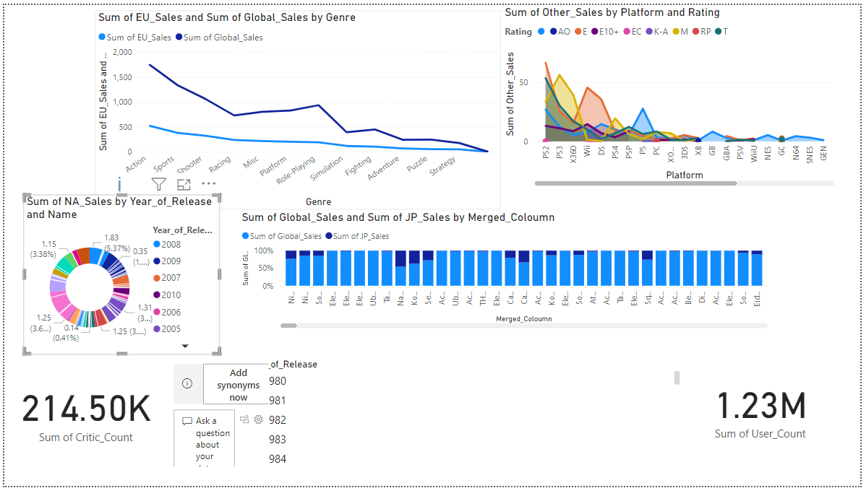

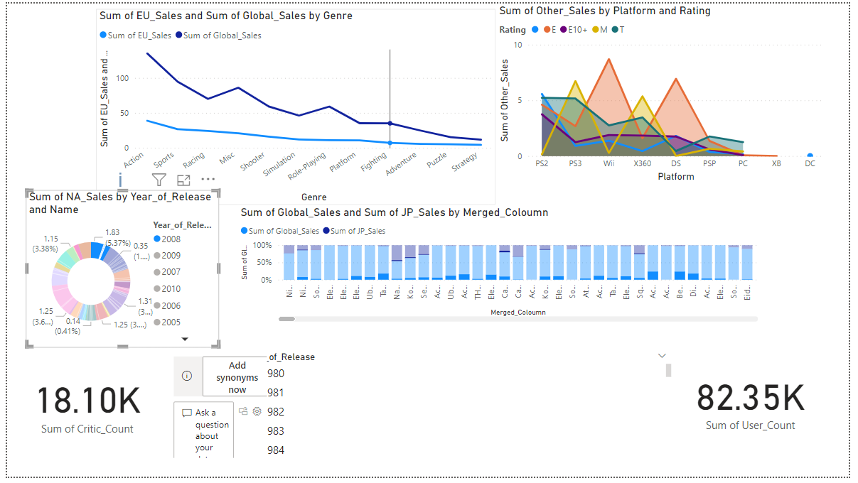

In this picture I clicket the year in sales by year of release the graph shows 2008 Sales Graph. I can see the sum of user count and critic count

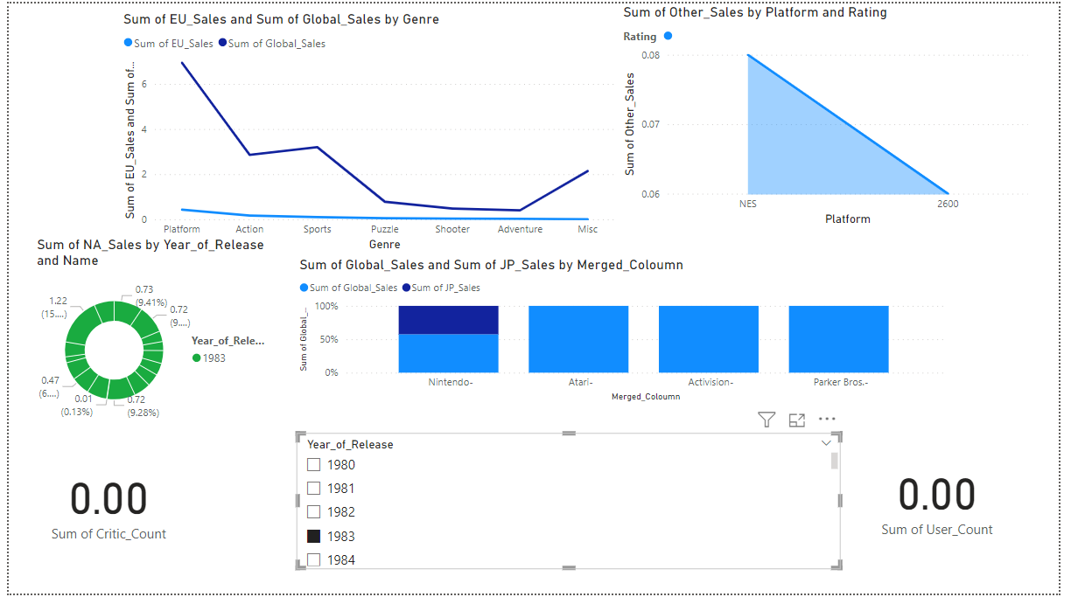

In this image I clicked the year of release 1983 in year of release then I got this results.

**PS4 Game Sales**

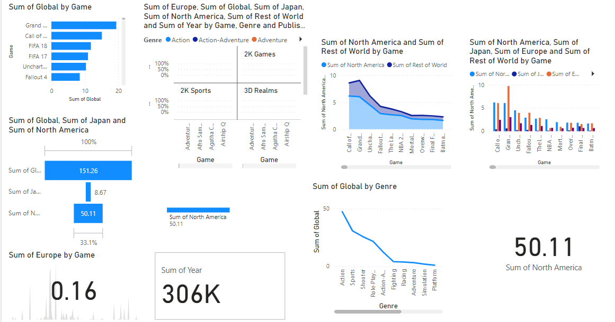

**Clicking the fifa game only**

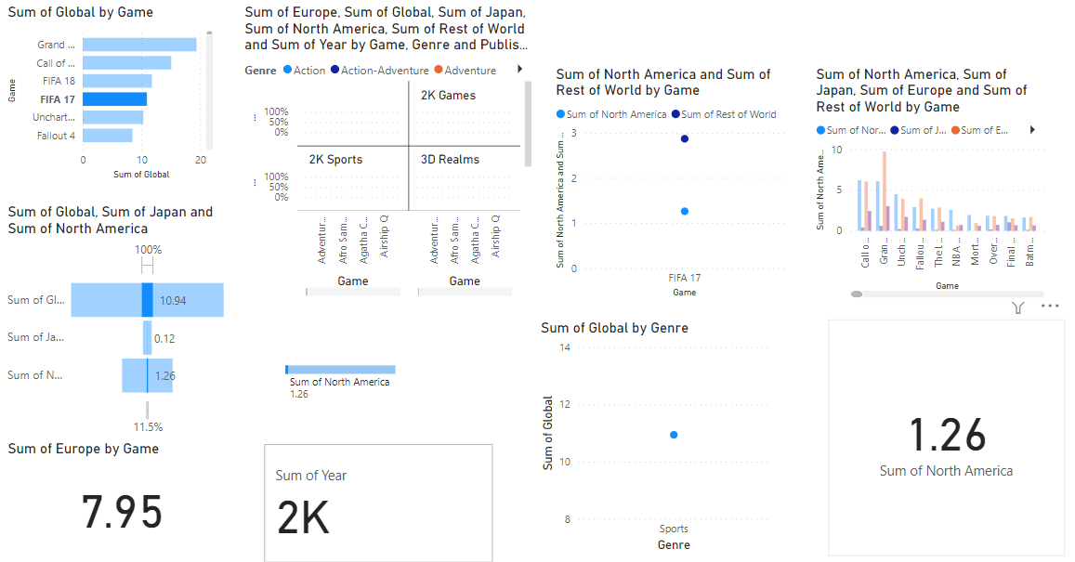

**XboxOne_GameSales**

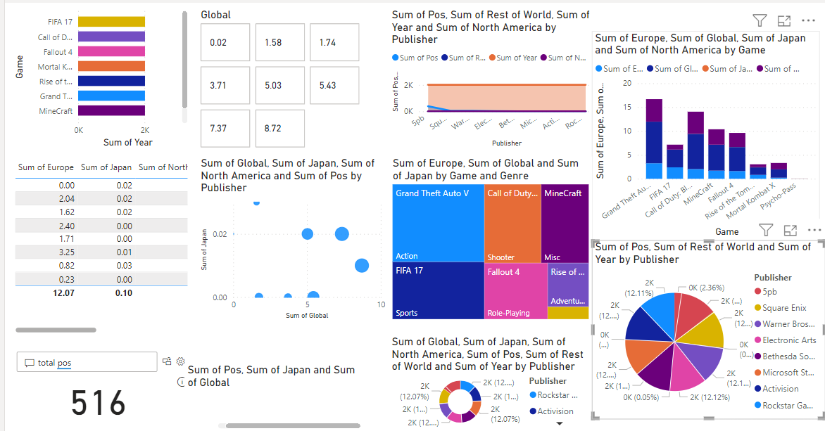

**Checking Global Sales**

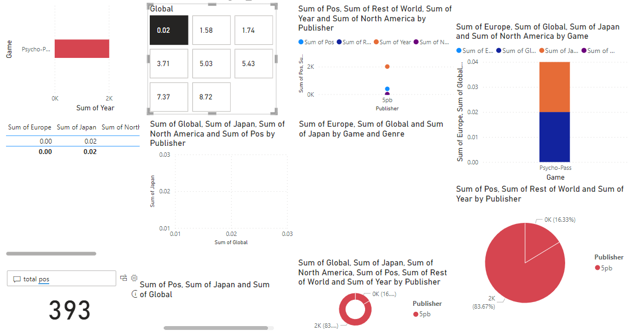

**Clicking a specific game**

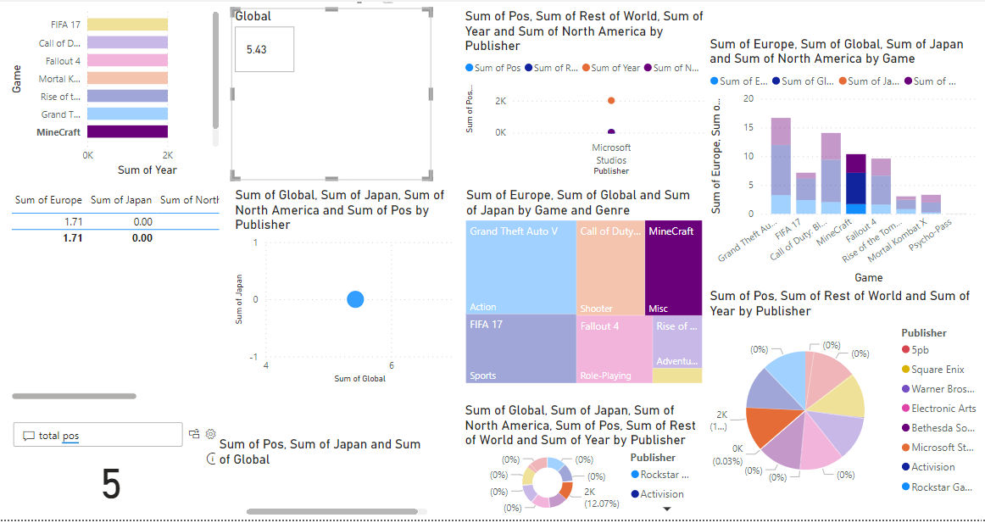

# 2. **Interpret the findings derived from the records manipulation to assist conclusions made.**

## Conclusions from the Power BI Dashboard:

1. Genre Popularity Analysis

The dashboard displays the distribution of sport genres based on sales. By perception which genres have historically performed well, Diesel Games can tailor its sport manufacturing method to align with famous trends.

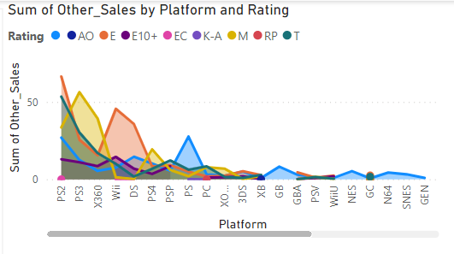

1. Platform Performance:

Visualizations showcase the performance of gaming platforms over time. This perception lets in Diesel Games to make knowledgeable choices about platform compatibility for their new game releases.

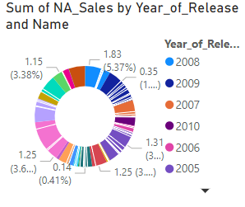

1. Regional Sales Impact:

The regional income analysis gives insights into the geographic preferences of gamers. Understanding regional variants helps Diesel Games personalize advertising techniques for unique audiences.

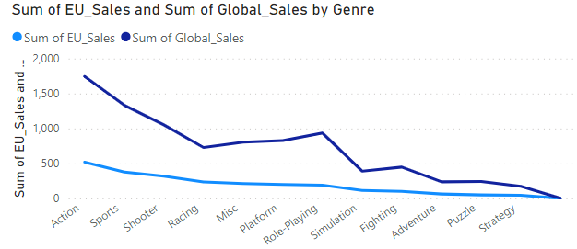

1. Correlation Between Critic and User Scores:

The dashboard explores the correlation between critic and user scores. This facts is precious for Diesel Games in gauging the affect of game opinions on income and ordinary reception.

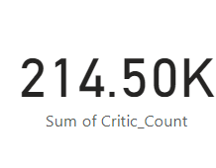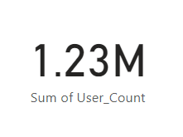

1. Top Selling Games:

A visual representation of the top-selling video games assists Diesel Games in identifying patterns and traits that make a contribution to commercial success. This data is instrumental in shaping future game development.

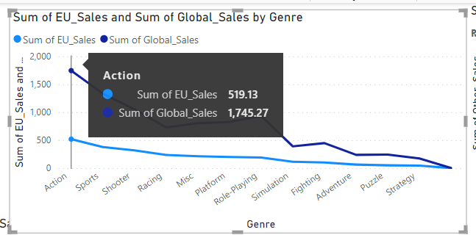

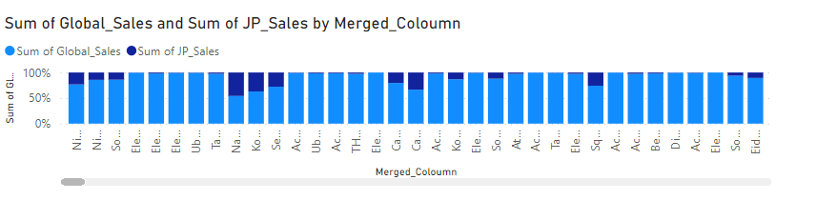

## Benefits and Business Implications:

1. Informed Game Development Strategies:

By examining style recognition and platform performance, Diesel Games can optimize its recreation improvement strategy. For example, if positive genres or platforms are trending, the enterprise can focal point assets on these areas.

Q&A

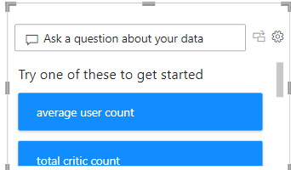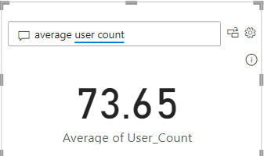

1. Targeted Marketing Campaigns:

Regional sales insights enable Diesel Games to tailor advertising campaigns to particular geographic preferences. This targeted approach can enhance user engagement and extend the probability of profitable game launches.

1. Quality Assurance Based on User and Critic Scores:

Understanding the correlation between critic and user scores helps Diesel Games prioritize excellent assurance efforts. If there is a sizable misalignment between the two, it signals potential problems that need attention.

1. Strategic Partnerships:

Identifying top-selling games and their characteristics affords valuable insights for strategic partnerships. Diesel Games can discover collaborations with successful builders or publishers to decorate its market position.

## Recommendations:

1. Continuous Monitoring:

Implement continuous monitoring of the dashboard to remain updated on industry trends, making sure that decision-makers have the contemporary records for strategic planning.

Like this checking yearly sales

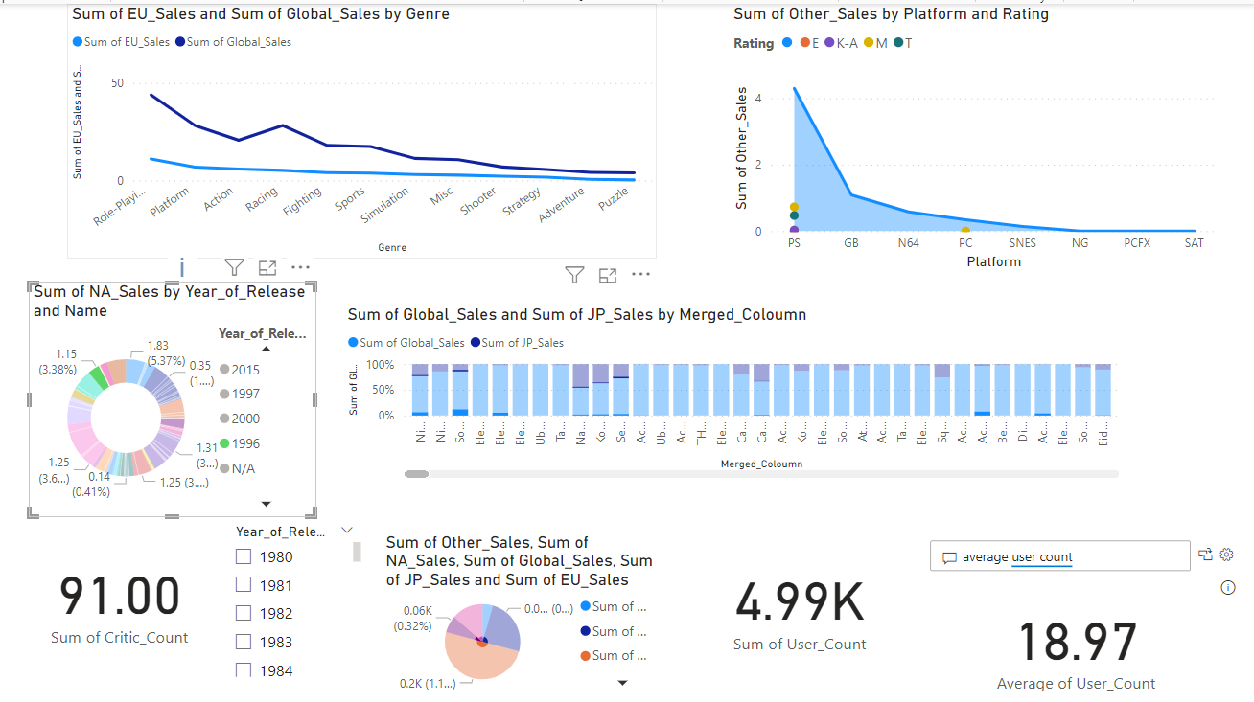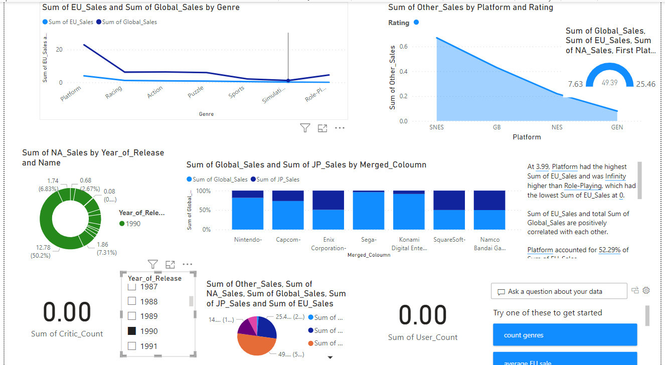

1. Expand Data Sources:

Consider increasing facts sources beyond video recreation sales, incorporating social media metrics, participant feedback, and rising technologies to enhance the depth of analysis.

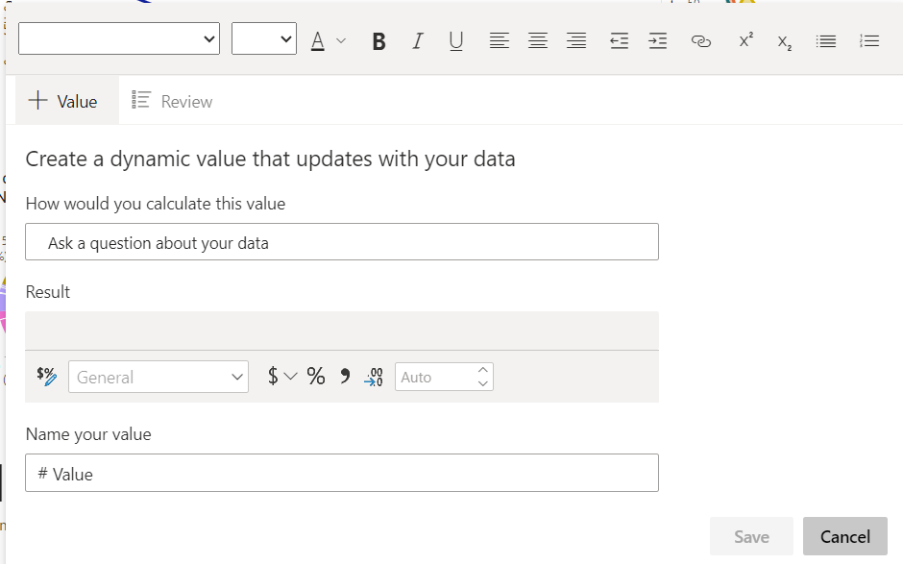

Like this writing a review on narrative form from customers. And need to anlayse like this

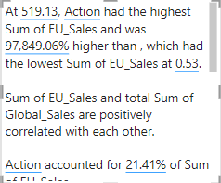

1. User Engagement Analysis:

Integrate data on participant engagement, such as playtime and in-game interactions, to attain a comprehensive perception of user conduct and preferences.

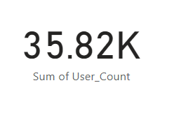

Get a count of yearly user engagement

1. Competitor Analysis:

Extend the analysis to consist of competitor performance, allowing Diesel Games to benchmark against industry leaders and become aware of areas for improvement.

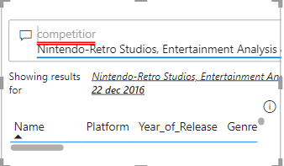

1. Player Demographics Analysis:

Utilize demographic statistics to apprehend the age, gender, and preferences of the gaming audience. This records can guide Diesel Games in tailoring sport content, features, and advertising techniques to higher resonate with their goal demographic.

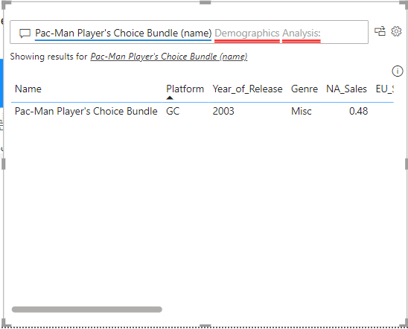

1. Seasonal Trends and Releases:

Analyze the impact of seasonal tendencies on game income and become aware of greatest release periods. By appreciation when positive genres or structures journey heightened popularity, Diesel Games can strategically time their sport launches for most impact.

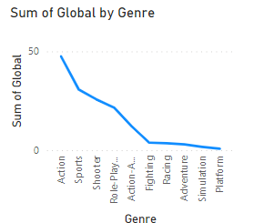

1. DLC and Microtransaction Insights:

Explore the performance of downloadable content material (DLC) and microtransactions in top-selling games. This records can help Diesel Games refine their monetization strategies, supplying content material or points that align with client preferences and maximize revenue.

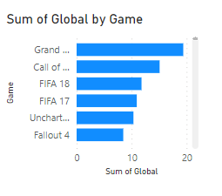

1. Technology Adoption Trends:

Investigate the adoption prices of new gaming technologies, such as virtual fact or augmented reality. This perception can help Diesel Games in staying beforehand of the curve, potentially exploring revolutionary sport improvement opportunities or partnerships.

1. Global Gaming Events Impact:

Analyze the influence of most important gaming activities on game sales and trends. This facts can guide Diesel Games in participating in or leveraging these activities to enhance marketing efforts and extend brand visibility.

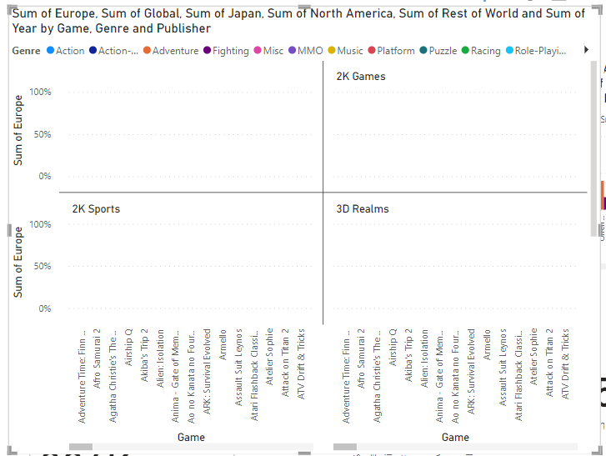

1. Social Media Sentiment Analysis:

Incorporate sentiment evaluation from social media structures to gauge the average appreciation of Diesel Games and their titles. This real-time comments can assist the organisation address issues quickly, capitalize on fantastic sentiment, and enhance neighborhood engagement.

1. Accessibility and Inclusivity Metrics:

Evaluate the accessibility and inclusivity features in top-selling games. This facts can guide Diesel Games in growing greater inclusive gaming experiences, appealing to a broader target market and aligning with enterprise tendencies towards diversity and accessibility.

Recommendation for Implementation:

Establish a cross-functional group involving information analysts, game developers, and advertising and marketing experts to collaboratively interpret and act upon the insights generated from the Power BI dashboard. This ensures a holistic method to decision-making and aligns quite a number components of the enterprise for most beneficial performance.

* Summary:

The Power BI dashboard no longer only demonstrates the functionality of information manipulation and automation however additionally gives actionable insights for Diesel Games. By leveraging these findings, the business enterprise can make knowledgeable selections in game production, development, marketing, and strategic partnerships. The non-stop use of such visualizations positions Diesel Games to remain aggressive and responsive to the dynamic gaming industry.

In conclusion, Power BI proves to be a precious tool for Diesel Games, offering a hassle-free interface, automation features, and powerful visualizations. The dashboard created for the "Video Games Sales" dataset showcases the practicable for data-driven decision-making in the gaming industry, aligning with Diesel Games' commitment to growing magical experiences for gamers.

**Analysis Of Regional Sales Impact**

1. **Dashboard Visualizations:**

* **Regional Sales Comparison Chart:**
* Evidence: A bar chart evaluating sales figures for each region.
* Interpretation: Analyze the bar chart to pick out areas with the easiest and lowest sales. The size of the bars gives a clear visible representation of relative income performance.
* Trend Line for Regional Sales Over Time:
* Evidence: Line chart illustrating the vogue of income in key regions over time.
* Interpretation: Examine the line chart to understand seasonal or long-term patterns in regional sales, helping in strategic decision-making concerning launch timings and advertising campaigns.

1. Meaningful Decisions:

* Targeted Marketing Strategies:
* Decision: Allocate advertising budgets primarily based on areas with consistently excessive sales.
* Reasoning: This ensures efficient aid utilization and maximizes the have an impact on of advertising campaigns the place they are possibly to yield the nice results.
* Localization of Game Content:
* Decision: Consider growing region-specific content material or adaptations.
* Reasoning: Tailoring video games to swimsuit regional preferences can decorate appeal and doubtlessly extend income in specific markets.
* Strategic Partnerships with Local Distributors:
* Decision: Explore partnerships with nearby distributors in high-performing regions.
* Reasoning: Collaborating with hooked up distributors can amplify visibility and accessibility, positively impacting income in these regions.
* Adjust Release Timing Based on Regional Trends:
* Decision: Optimize sport release timings thinking about regional sales trends.
* Reasoning: Launching games when a unique location is extra receptive can lead to higher preliminary income and sustained interest.
* Localized Promotions and Events:
* Decision: Design promotions or activities tailored to specific regions.
* Reasoning: Customized advertising initiatives can resonate more correctly with neighborhood audiences, fostering neighborhood engagement and boosting sales.
* Investigate Underperforming Regions:
* Decision: Conduct a deeper analysis of areas with consistently low sales.
* Reasoning: Understanding the motives behind underperformance can inform corrective moves or pick out untapped opportunities for improvement.

**Implementation in Power BI:**

* Dynamic Filters: Enable customers to filter the dashboard by using region, permitting for a nearer seem to be at particular markets.
* Drill-Down Features: Implement drill-down functionality to discover targeted sales information for individual nations within every region.
* Comparative Analysis: Utilize Power BI aspects to evaluate regional income in opposition to world benchmarks or enterprise averages for contextual insights.

By adapting the interpretation, the absence of the Geographical Heatmap does now not substantially have an impact on the capacity to make informed selections primarily based on regional income records in the Power BI dashboard.

**Screen Shots Of Data Cleaning Process**

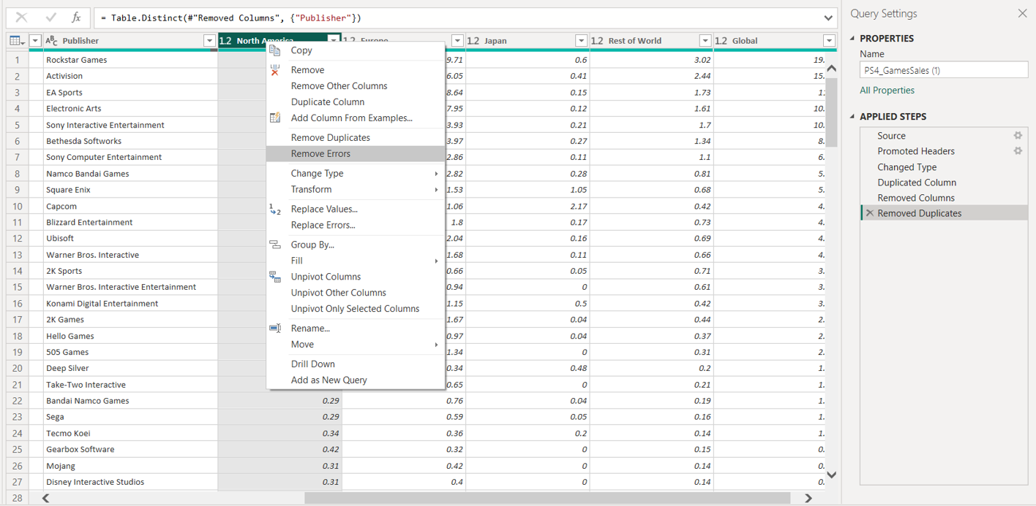

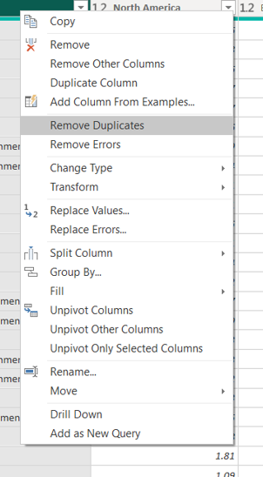

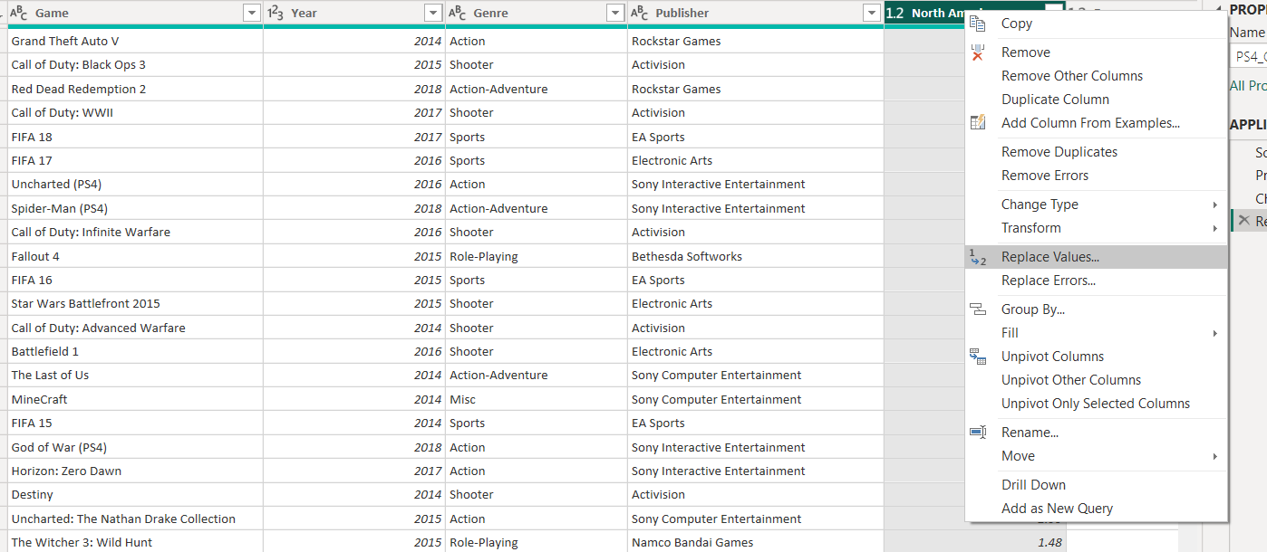

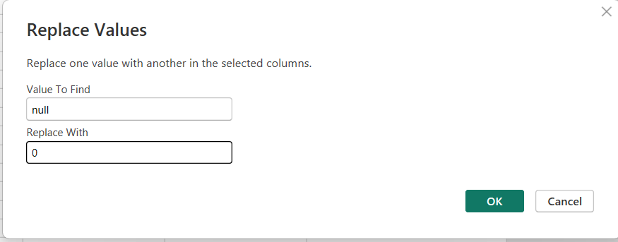

# Diesel Games to have an impact on its business decisions concerning the design and production of video games.

## Emphasis on Emotional Impact and Normal Experience:

Conclusion: Diesel Games ought to prioritize game factors that beautify emotional have an effect on and deliver a ordinary gaming experience.

Recommendation: Invest in storytelling, personality development, and person engagement to create emotionally resonant games. Conduct market lookup to apprehend participant preferences for immersive and relatable experiences.

## Success on the App Store:

Conclusion: Diesel Games has a successful track file with three games constantly rating in the pinnacle 10 paid-for games on the App Store.

Recommendation: Continue to focus on the mobile gaming platform, optimizing video games for the App Store. Consider partnerships with the platform to decorate visibility and consumer acquisition. Regularly replace and improve existing games to keep their relevance.

## Mission to Make Magic Real:

Conclusion: Diesel Games pursuits to create magical and immersive gameplay experiences for gamers.

Recommendation: Maintain the commitment to creating magical experiences by exploring modern game mechanics, virtual actuality (VR), augmented actuality (AR), or other emerging technologies. Engage with participant remarks to apprehend what elements of gameplay contribute to the sense of magic.

## Global Headquarters in London:

Conclusion: Diesel Games is headquartered in London, England.

Recommendation: Consider expanding the company's presence to other gaming hubs or markets to faucet into various intelligence swimming pools and attain a broader audience. Explore collaborations with international game builders or studios.

## Consistent Top 10 Paid-For Games Ranking:

Conclusion: Consistent success in the pinnacle 10 paid-for games shows a robust monetization approach and player willingness to pay.

Recommendation: Continue refining monetization models, ensuring a stability between in-app purchases, ads (if any), and initial sport purchase costs. Consider implementing loyalty packages or in-game events to encourage player spending.

## Commitment to Immersive Gameplay:

Conclusion: Diesel Games is dedicated to creating immersive gameplay experiences.

Recommendation: Invest in applied sciences that beautify immersion, such as extremely good graphics, practical sound design, and interactive storytelling. Stay abreast of industry trends to contain modern-day aspects that make contributions to immersive gameplay.

In summary, Diesel Games proceed to prioritize emotional affect and immersive gameplay, capitalize on its success on the App Store, discover global expansion, and remain revolutionary in game development. Regularly analyzing player comments and market trends will be fundamental in adapting techniques for sustained success.

# Task 04

1.Introduction:  
  
In the fast-evolving landscape of current business, the adoption of a data-driven lifestyle has grow to be instrumental for groups searching for a competitive edge. At the heart of this cultural shift are records specialists, folks with the understanding to extract significant insights from complex datasets. While the blessings of a data-driven approach are evident, facts professionals come upon unique challenges that warrant careful consideration. This comparison delves into the impact of key issues confronted by using facts specialists in a data-driven culture, shedding light on the significance of non-stop skills development, information first-rate and governance, superb communication, and overcoming resistance to change. Understanding these challenges is paramount to fostering an surroundings where facts experts can thrive and contribute significantly to organizational success

# 2.Roles and Responsibilities of BI Developers in a Data-Driven Culture

Business Intelligence (BI) builders play a crucial role in a data-driven subculture by way of leveraging statistics to furnish insights that inform commercial enterprise decisions. In the context of Diesel Games, the place data can be valuable for perception player behavior, optimizing game features, and riding enterprise strategies, BI developers would have unique roles and responsibilities. Here are some key roles and duties for BI builders at Diesel Games:

1. **Data Analyst:**

Role: Analyzing giant datasets to extract significant insights and trends associated to participant behavior, recreation performance, and market dynamics.

* Responsibilities:

Conducting exploratory data evaluation to pick out patterns and correlations.

Generating normal reviews on key overall performance indicators (KPIs) for games.

Providing actionable pointers based totally on data-driven insights.

1. **Database Designer/Developer:**

Role: Designing and developing databases to successfully shop and retrieve game-related data.

* Responsibilities:

Designing database schemas to support the storage of player profiles, in-game transactions, and different relevant data.

Developing and keeping database buildings for most advantageous performance.

Ensuring facts integrity and security within the database.

1. **ETL Developer (Extract, Transform, Load):**

Role: Building and preserving the ETL processes to extract, transform, and load information from more than a few sources into the BI system.

* Responsibilities:

Extracting facts from recreation servers, third-party APIs, and other relevant sources.

Transforming uncooked data into a format suitable for analysis.

Loading processed facts into the BI gadget for reporting and analysis.

1. **Report Developer:**

Role: Creating interactive and visually appealing reports and dashboards for stakeholders.

* Responsibilities:

Designing and developing reviews that spotlight key metrics and trends.

Ensuring reviews are basic and reachable to non-technical stakeholders.

Collaborating with commercial enterprise teams to recognize reporting requirements.

1. **Data Quality Analyst:**

Role: Monitoring and making sure the exceptional and accuracy of information used in BI techniques and reports.

* Responsibilities:

Implementing information validation checks to identify and rectify anomalies.

Collaborating with data source proprietors to tackle statistics quality issues.

Establishing and enforcing statistics exceptional standards.

1. **BI Project Manager:**

Role: Overseeing BI projects, coordinating activities, and ensuring timely transport of BI solutions.

* Responsibilities:

Managing the BI improvement lifecycle, from requirements gathering to deployment.

Coordinating with cross-functional teams to align BI initiatives with commercial enterprise goals.

Communicating undertaking reputation and managing stakeholder expectations.

1. **Business Intelligence Architect:**

Role: Defining the standard BI structure and making sure alignment with business objectives.

* Responsibilities:

Designing scalable and maintainable BI solutions.

Evaluating and deciding on BI equipment and technologies.

Providing coaching on quality practices for BI development.

In the case of Diesel Games, these roles and responsibilities mutually make contributions to harnessing the energy of statistics for knowledgeable decision-making, bettering participant experiences, and optimizing business techniques within the gaming industry.

# 3.Business Intelligence (BI) Trends and Innovations:

1. AI and Machine Learning Integration:

Increasing integration of AI and machine learning algorithms for predictive analytics and automatic insights generation.

Evidence: Many BI tools, such as Tableau and Power BI, have introduced AI-driven points for automated insights and trend predictions.

1. Self-Service BI:

Trend: Empowering non-technical customers to create their own reports and dashboards without relying on IT support.

Evidence: Tools like Microsoft Power BI and Tableau provide intuitive interfaces for users to create and customize reports except deep technical knowledge.

1. Data Governance and Compliance:

Growing emphasis on statistics governance, security, and compliance with policies (e.g., GDPR).

Evidence: BI equipment are incorporating elements for facts lineage tracking, access controls, and audit trails to make certain compliance.

1. Real-time Analytics:

Increasing demand for real-time analytics to enable quick decision-making.

Evidence: BI platforms are improving their capabilities to technique and visualize real-time data, enabling timely insights.

**Data Visualization Trends and Innovations:**

1. Interactive and Exploratory Visualization:

Shift closer to extra interactive and exploratory visualization, allowing users to manipulate and analyze statistics in real-time.

Evidence: Tools like Tableau and Qlik Sense grant interactive features, enabling customers to discover records dynamically.

1. Augmented Analytics:

Integration of augmented analytics to decorate records exploration with AI-driven guidelines and insights.

Evidence: BI structures are incorporating smart facets that provide automated insights and tips at some point of information exploration.

1. Natural Language Processing (NLP):

Integration of NLP for querying and interacting with information using natural language.

Evidence: Some BI tools enable customers to ask questions in herbal language to generate corresponding visualizations.

**Big Data Trends and Innovations:**

1. Edge Computing for Big Data:

Utilizing area computing to process and analyze statistics closer to the source, decreasing latency.

Evidence: Edge analytics solutions are gaining popularity in eventualities the place real-time processing is critical.

1. Data Lakes and Multi-Cloud Deployments:

Adoption of records lakes and multi-cloud techniques for storing and managing large volumes of diverse data.

Evidence: Many agencies are leveraging cloud systems like AWS, Azure, and Google Cloud for scalable storage and processing of huge data.

1. Blockchain in Data Management:

Exploring the use of blockchain for secure and obvious facts management.

Evidence: Some industries are experimenting with blockchain to decorate the security and integrity of big statistics transactions.

While these developments are general, Diesel Games might also gain from considering these that align with its unique business targets and data-driven goals. It's recommended to stay up to date on the contemporary enterprise reports and attend relevant conferences for the most recent improvements and traits in BI, Data Visualization, and Big Data.

# 4. Evaluate the have an impact on of the key issues faced through statistics professionals when working in a data-driven culture.

In the era of data-driven cultures, companies are an increasing number of recognizing the pivotal position of data experts in extracting actionable insights from complex datasets. While the benefits of a data-driven culture are substantial, statistics professionals come upon numerous challenges that can substantially impact their effectiveness within an organization.

One of the foremost challenges confronted with the aid of records specialists is the need for non-stop competencies development. The field of information analysis is dynamic, evolving unexpectedly with the emergence of new tools, techniques, and methodologies. To stay applicable and contribute efficaciously to decision-making processes, data specialists need to consistently update their skills. Training programs and professional development opportunities grow to be imperative to make sure that records experts are well-equipped to harness the full potential of equipment like Power BI and navigate the ever-changing landscape of facts analytics.

Continuous gaining knowledge of entails now not only learning new tools but also staying abreast of industry great practices and evolving methodologies. This proactive approach is integral for facts experts to adapt to the evolving data landscape, making sure their analyses stay insightful and relevant. Organizations that invest in the ongoing schooling of their records professionals are better placed to leverage the trendy advancements in statistics analytics, gaining a aggressive edge in an increasingly more data-driven world.

Another imperative project confronted by data professionals in a data-driven way of life is the assurance of information high-quality and governance. The success of any data-driven initiative hinges on the accuracy and reliability of the underlying data. Data experts must grapple with the complexities of keeping data integrity, ensuring statistics security, and complying with regulatory requirements.

To tackle these challenges, collaboration between facts specialists and IT departments is paramount. Data experts need to work intently with IT authorities to set up strong data governance insurance policies and frameworks. This collaborative effort ensures that information is not solely accurate however also impenetrable and compliant with industry regulations. Without a strong basis in records governance, agencies hazard making selections based totally on flawed or unreliable data, potentially main to high-priced errors and misjudgments.

Communication is another indispensable element regularly underestimated in the data-driven tradition paradigm. While records professionals excel in deciphering complicated datasets and deriving significant insights, their effectiveness hinges on their capability to talk these findings to non-technical stakeholders. Bridging the gap between technical information and layman perception is a skill that records professionals must cultivate.

Training packages that focus on enhancing conversation competencies are integral for data experts to carry their insights in a comprehensible manner. Visualization strategies and storytelling methodologies end up imperative tools in their arsenal, enabling them to current complicated information in a way that resonates with decision-makers across more than a few departments. Effective conversation ensures that the valuable insights derived by facts professionals are now not misplaced in translation and can power informed decision-making at all organizational levels.

Moreover, resistance to exchange within the agency poses a considerable hurdle for statistics professionals aiming to set up and maintain a data-driven culture. Employees accustomed to traditional decision-making tactics may also exhibit reluctance closer to adopting data-driven practices. Overcoming this resistance requires a aggregate of trade management strategies, tremendous communication, and the showcasing of success stories.

Change management strategies involve developing a compelling case for the advantages of a data-driven culture, highlighting how it aligns with organizational desires and leads to increased outcomes. Communication performs a critical position in this process, as data professionals want to articulate the high quality have an impact on of data-driven practices on decision-making, efficiency, and normal business success. Additionally, showcasing success tales – cases where data-driven insights have at once influenced high-quality results – serves as effective proof of the price that a data-driven way of life can carry to the organization.

In conclusion, while the benefits of a data-driven tradition are undeniable, records specialists face multifaceted challenges that demand strategic interventions. Continuous learning, sturdy information governance, positive communication, and adept trade management are quintessential aspects of a profitable data-driven organization. By addressing these challenges, corporations can empower their records professionals to navigate the complexities of the information landscape and extract meaningful insights that drive knowledgeable decision-making, eventually fostering a tradition the place information is a strategic asset as an alternative than a doable liability.

# 5.Different strategies and concerns

## Strategies of BI Developers:

1. Data Modeling and Architecture:

BI developers format and implement robust records models and architectures to ensure data accuracy, consistency, and efficiency.

Evidence: Utilizing tools like ERwin Data Modeler, developers can create visual representations of statistics structures, relationships, and flow, facilitating a higher grasp of the information environment.

1. ETL (Extract, Transform, Load) Processes:

BI developers hire high-quality ETL techniques to extract, transform, and load statistics from a range of sources into the BI system.

Evidence: Tools like Apache Nifi, Talend, or Microsoft SSIS are often used to automate ETL workflows, making sure well timed and accurate data integration.

1. Data Quality Management:

Implementing facts excellent management practices to make sure the accuracy, completeness, and consistency of data.

Evidence: BI developers use equipment like Trifacta or Informatica Data Quality to profile, clean, and standardize data, addressing issues associated to information quality.

1. Self-Service BI Enablement:

Empowering end-users with self-service BI equipment to create their very own reviews and visualizations, reducing dependency on IT.

Evidence: BI systems like Tableau, Power BI, and Looker grant easy interfaces, permitting non-technical customers to create and discover information visualizations.

1. Advanced Analytics and Machine Learning Integration:

Integrating advanced analytics and machine studying algorithms to derive actionable insights from data.

Evidence: BI equipment are incorporating predictive analytics capabilities, permitting developers to construct and deploy desktop getting to know fashions for forecasting and style analysis.

1. Real-time Analytics:

Implementing options for real-time analytics to allow timely decision-making.

Evidence: Technologies like Apache Kafka or AWS Kinesis facilitate the processing of streaming data, allowing BI developers to create real-time dashboards and reports.

## Concerns of BI Developers:

1. Data Security and Compliance:

Concern is Ensuring that sensitive data is treated securely and in compliance with statistics protection regulations.

Mitigation: Implementing encryption, get entry to controls, and auditing mechanisms. Regularly updating safety protocols to align with enterprise requirements and regulations.

1. Scalability and Performance:

Addressing problems related to the scalability and performance of BI systems, in particular as records volumes grow.

Mitigation: Optimizing queries, the usage of in-memory processing, and scaling infrastructure horizontally or vertically to meet performance requirements. Regularly monitoring and fine-tuning the machine for foremost performance.

1. Data Governance:

Ensuring that statistics is governed effectively, preserving information quality, and adhering to organizational standards.

Mitigation: Establishing statistics governance frameworks, enforcing metadata management, and conducting everyday audits. Collaborating with statistics stewards and commercial enterprise customers to outline and put in force data governance policies.

1. User Adoption and Training:

Ensuring that end-users undertake BI tools successfully and are trained to leverage the capabilities for knowledgeable decision-making.

Mitigation: Providing comprehensive education programs, developing hassle-free documentation, and fostering a tradition of data-driven decision-making within the organization.

1. Integration with Business Processes:

Aligning BI solutions with present business processes to make sure seamless integration and relevance.

Mitigation: Collaborating closely with enterprise stakeholders, perception their needs, and integrating BI into workflows. Regularly updating BI solutions to accommodate changes in enterprise processes.

In summary, BI builders implement strategies to harness the energy of information while addressing issues associated to data security, scalability, governance, consumer adoption, and integration with commercial enterprise processes. The proof furnished demonstrates the tools and technologies typically used in the industry to put into effect these strategies.

## Different strategies used by BI developers to ensure data compliance(Review).

Ensuring facts compliance is a imperative aspect of BI development, mainly in the context of privateness rules and organizational governance. Here's a assessment of exclusive techniques used with the aid of BI developers to make certain facts compliance:

1. Data Masking and Anonymization:

Strategy: BI builders hire information covering and anonymization techniques to protect sensitive information, ensuring that personally identifiable data (PII) is not exposed in reviews or analytics.

Review: This approach helps in complying with privateness regulations such as GDPR by safeguarding individual identities whilst nevertheless allowing meaningful analysis. Tools like IBM InfoSphere Optim and Oracle Data Masking are regularly used for this purpose.

1. Role-Based Access Control (RBAC):

Implementing RBAC ensures that customers have get right of entry to solely to the data relevant to their roles and responsibilities. This restricts unauthorized access to touchy information.

Review: RBAC is a integral approach for information compliance, imparting a granular degree of manage over who can access, view, and manipulate data. BI structures like Tableau and Power BI regularly include RBAC features.

1. Data Encryption:

BI developers apply encryption techniques to protect data each in transit and at rest. This adds an greater layer of security, making it harder for unauthorized entities to access sensitive information.

Review: Encryption is a widely regularly occurring exercise for data compliance, and it helps groups meet quite a number regulatory requirements. BI equipment may also utilize SSL/TLS for statistics in transit and encryption algorithms for records at rest.

1. Audit Trails and Monitoring:

Implementing comprehensive audit trails and monitoring structures permits BI builders to track user activities, facts accesses, and changes. This helps in identifying and addressing workable compliance issues.

Review: Regularly reviewing audit logs ensures transparency and accountability, demonstrating compliance with guidelines that require monitoring facts get entry to and usage.

1. Data Classification and Tagging:

Classifying and tagging facts primarily based on sensitivity levels helps in implementing records compliance policies. It allows BI developers to apply exceptional safety measures to information based totally on its classification.

Review: Data classification simplifies the enforcement of compliance insurance policies and ensures that fabulous security measures are utilized to exceptional categories of data.

1. Data Governance Framework:

Establishing a sturdy facts governance framework entails defining policies, roles, and duties related to information management and compliance.

Review: A well-defined records governance framework gives tips for BI builders and other stakeholders, ensuring that information compliance is ingrained in organizational processes.

1. Regular Compliance Audits:

Conducting normal compliance audits includes reviewing BI systems, information handling processes, and security measures to become aware of and rectify any attainable compliance gaps.

Review: Regular audits help in proactively addressing compliance issues and adapting to evolving regulatory requirements. It ensures that BI structures continue to be aligned with enterprise standards and regulations.

In conclusion, the reviewed techniques at the same time contribute to a comprehensive method to information compliance in BI development. BI developers must proceed to continue to be knowledgeable about the ultra-modern regulatory developments and industry exceptional practices to make sure that their strategies continue to be high quality and up-to-date.

# 6. Evaluate how nicely the chosen facts coaching and manipulation methods, the equipment selected, and the information derived have aided the decision-making method for Diesel Games.

Diesel Games, a prominent player in the gaming industry, proven strategic acumen via deciding on Power BI as their main tool for data guidance and manipulation. This decision has profoundly impacted and more advantageous the decision-making approaches inside the organization. Power BI's amalgamation of an intuitive interface and effective abilities for statistics cleaning, transformation, and integration has streamlined Diesel Games' records education workflows.

The facts guidance methods chosen by way of Diesel Games encompass a complete method to dealing with various datasets. Power BI's Power Query and M Language abilities have played a pivotal role in this process. The versatility of Power BI in connecting to more than a few facts sources and executing transformations has resulted in sizeable time savings and ensured the accuracy of the facts being processed.

Cleaning and standardizing various datasets is a critical step in statistics preparation. Power BI's Power Query provides a uncomplicated interface for defining and executing data cleaning operations. Whether it is managing lacking values, correcting inconsistencies, or standardizing formats, Power BI empowers Diesel Games to preserve records integrity effectively.

The extraction of applicable points and the transformation of raw facts into meaningful insights are vital degrees in the information training journey. Power BI's M Language, a effective scripting language within Power Query, lets in for difficult records transformations. Diesel Games can create reusable queries, practice complex transformations, and derive valuable insights that make a contribution to informed decision-making.

The interactive visualizations generated the use of Power BI serve as a cornerstone for multiplied comprehension of complex datasets. Dashboards and reports, crafted with Power BI's visualization tools, present key performance indications (KPIs) and quintessential metrics in a visually appealing manner. This visual clarity empowers decision-makers at Diesel Games to swiftly interpret trends, pick out patterns, and spot outliers, facilitating proactive and knowledgeable decision-making.

The integration of desktop getting to know algorithms inside Power BI represents a forward-looking strategy to decision-making. Predictive analytics, trend forecasting, and anomaly detection models, powered by means of Power BI's machine studying capabilities, enable Diesel Games to expect future consequences and become aware of doable challenges or opportunities. This predictive capability positions Diesel Games at the forefront of proactive decision-making in the dynamic gaming industry.

The influence of Power BI on decision-making extends past the operational level; it appreciably influences strategic planning. The capacity to analyze historic trends, forecast future performance, and identify boom possibilities empowers Diesel Games to make informed decisions concerning long-term investments, strategic partnerships, and the prioritization of recreation development efforts.

However, it's quintessential to understand that the effectiveness of these tools is contingent on a strong perception of the commercial enterprise context and the underlying data. Diesel Games need to ensure that its personnel obtain sufficient training and aid to maximize the advantages of Power BI. A knowledgeable and empowered personnel is crucial for sustained success in leveraging records for decision-making.

In conclusion, Diesel Games' strategic desire of Power BI for facts preparation and manipulation has yielded great benefits. The streamlined workflows, versatile capabilities, and predictive analytics supplied via Power BI have enhanced decision-making procedures at both operational and strategic levels. As Diesel Games continues to navigate the dynamic gaming industry, the strong foundation laid by way of Power BI positions the organization for persisted success in data-driven decision-making

7.Conclusion:  
  
In conclusion, the trip toward a data-driven lifestyle is marked by way of both promise and complexity. Data specialists, the architects of this cultural transformation, navigate a landscape rife with challenges. The necessary for non-stop competencies development, the fundamental function of data first-rate and governance, the often overlooked aspect of fine communication, and the formidable resistance to change all underscore the nuanced nature of this transition. Organizations that acknowledge and address these challenges through strategic investments in training, governance frameworks, communication enhancement, and exchange administration stand to reap the full benefits of a data-driven paradigm. Empowering information professionals in these areas now not only ensures the integrity of decision-making techniques but additionally positions the enterprise at the forefront of innovation in an technology the place records is a strategic asset shaping the future of business.

# Reference list

Anon, (2018). *Fundamentals of Big Data Analytics - Run Data Analysis on Your Own*. [online] Available at: https://elysiumacademy.org/big-data-analytics-fundamentals/#:~:text=Fundamentals%20of%20Big%20Data%20Analytics%20is%20the%20process%20of%20transforming.

careerfoundry.com. (n.d.). *Become a designer, developer or data analyst from scratch*. [online] Available at: https://careerfoundry.com/.

Chapman, C. (2019). *A Complete Overview of the Best Data Visualization Tools*. [online] Toptal Design Blog. Available at: https://www.toptal.com/designers/data-visualization/data-visualization-tools.

Cielen, D., Meysman, A. and Ali, M. (n.d.). *M A N N I N G Big data, machine learning, and more, using Python tools*. [online] Available at: http://bedford-computing.co.uk/learning/wp-content/uploads/2016/09/introducing-data-science-machine-learning-python.pdf.

Gandomi, A. and Haider, M. (2015). Beyond the Hype: Big Data Concepts, Methods, and Analytics. *International Journal of Information Management*, 35(2), pp.137–144.

Hehman, E. and Xie, S.Y. (2021). Doing Better Data Visualization. *Advances in Methods and Practices in Psychological Science*, [online] 4(4), p.251524592110453. doi:https://doi.org/10.1177/25152459211045334.

Insights. (2021). *Big Data Visualization Techniques*. [online] Available at: https://bambooagile.eu/insights/big-data-visualization-techniques/.

Kaggle (2022). *Kaggle: Your Home for Data Science*. [online] Kaggle.com. Available at: https://www.kaggle.com/.

Kalyan, P. (2021). *What is Power BI? Architecture, Features and Components*. [online] Analytics Vidhya. Available at: https://www.analyticsvidhya.com/blog/2021/12/a-comprehensive-guide-on-data-visualisation-with-power-bi/.

Kumar, A. (2022). *What are the Roles and Responsibilities of a Data Scientist| Emeritus India*. [online] Emeritus - Online Certificate Courses | Diploma Programs. Available at: https://emeritus.org/in/learn/what-are-the-roles-and-responsibilities-of-a-data-scientist/.

Oracle (2015). *Oracle | Integrated Cloud Applications and Platform Services*. [online] Oracle.com. Available at: https://www.oracle.com/.

Panneerselvam, J., Liu, L. and Hill, R. (2015). An Introduction to Big Data. *Application of Big Data for National Security*, pp.3–13. doi:https://doi.org/10.1016/b978-0-12-801967-2.00001-x.

Partida, D. (2022). *Advantages and Disadvantages of Big Data | HackerNoon*. [online] hackernoon.com. Available at: https://hackernoon.com/advantages-and-disadvantages-of-big-data.

Rock Content. (2020). *Big data visualization: what it is, techniques and best tools*. [online] Available at: https://rockcontent.com/blog/big-data-visualization/.

Rossi, L., Badel, A., Hugues Bajas, Bajko, M., Ballarino, A., Barth, C., Ulrich, Luca Bottura, Broggi, F., Chiuchiolo, A., Dhalle, M., Durante, M., Philippe Fazilleau, J. Fleiter, Feng, Y., Goldacker, W., Kario, A., Kirby, G., Haro, E. and J. Himbele (2018). The EuCARD2 Future Magnets Program for Particle Accelerator High-Field Dipoles: Review of Results and Next Steps. 28(3), pp.1–10. doi:https://doi.org/10.1109/tasc.2017.2784357.

scientistcafe.com. (n.d.). *Statistics = Science + Art*. [online] Available at: https://scientistcafe.com/ [Accessed 9 Feb. 2024].

Simplilearn (2021). *Challenges of big data: Basic concepts, case study, and more*. [online] Simplilearn.com. Available at: https://www.simplilearn.com/challenges-of-big-data-article.

Sivarajah, U., Kamal, M.M., Irani, Z. and Weerakkody, V. (2017). Critical analysis of Big Data challenges and analytical methods. *Journal of Business Research*, [online] 70(1), pp.263–286. Available at: https://www.sciencedirect.com/science/article/pii/S014829631630488X.

